

CANDIDATE INFORMATION BOOKLET

PLEASE READ CAREFULLY
Assistant Architect
2 Year – Specific Purpose Contract

CLOSING DATE FOR RECEIPT OF COMPLETED APPLICATIONS:

4.00pm Friday 10 January 2025

______________________________________________________________________________
Contact:
Human Resources Department
Galway City Council
City Hall
College Road
Galway
H91 X4K8

Email: recruitment@galwaycity.ie
Telephone Number: 091-536596
______________________________________________________________________________

IMPORTANT CHECKLIST
Please check the following points before sending this form:

- All application forms must be submitted, fully completed (i.e. Section 1 & Section 2) and inclusive of all the requested documentation by 4.00pm on Friday, 10 January 2025. All incomplete applications will be returned as invalid after the closing date and will not be included in the competition.

- All information must only be provided on the formal application form. Additional information via Curriculum Vitae will not be considered.

- Ensure that your application form is completed in typed format, and you have answered all questions fully.

- Email Applications: The completed application form, along with scanned copies of relevant Educational Qualifications including results transcripts & Drivers licence (if applicable) must be submitted via email to recruitment@galwaycity.ie by 4.00pm on Friday, 10 January 2025. Please ensure subject bar of email states “Assistant Architect - Application Form”

- Original certificates will be required prior to any appointment. Applications submitted that do not meet the requirements as outlined will be deemed invalid, will be returned to the candidate and will NOT be included in the next stage of competition.

- Please note that a previous submission of relevant Education Qualifications to this office will not suffice as fulfilling the current application requirements.

- Applications will be short-listed on the basis of the information provided on the application form and therefore you should ensure that you have fully completed your application, and all documentation requested is submitted.

- Candidates should allow sufficient time to ensure delivery is not later than the latest time for acceptance. The responsibility rests with the applicant to ensure the application form, in full, is received on time by the Human Resources Department, Galway City Council.

- Please notify the Human Resources Department of any change of address. Please ensure that you include a current valid contact number and current email address on your application form.

JOB DESCRIPTION

Galway City Council has an exciting opportunity for the role of Assistant Architect on the basis of a 2 year specific purpose contract and is inviting applications from suitably qualified persons for the above competition.

The Assistant Architect works as part of a multi-disciplinary team within Galway City Council’s Planning and Housing Directorates to deliver key local authority services which include social housing, recreation and amenity provision and community development.

The role requires a clear knowledge and understanding of local authority services and its key stakeholders and relationships, local government structures and its democratic role and mandate, current local government issues, future trends and strategic direction of the sector, management and implementation of change, and Public Works Contracts.

The Assistant Architect shall operate under the direction of and report to the Senior Executive Architect to which they are assigned. They must undertake those duties as assigned to them by their Supervisor.

Notwithstanding the requirements of the post successful applicants may be assigned to any service area/role within the Local Authority at an analogous level by the Chief Executive at any time.

Architects’ Department Galway City Council:

The main objective of the Architect’s department is the delivery of Housing. We do this in two ways; in house design and working with consultants (Coady’s, O'Briain Beary, TAKA, Hall McKnight to name a few). At present we have three major housing developments on the boards along with a new homeless centre and smaller infill projects.

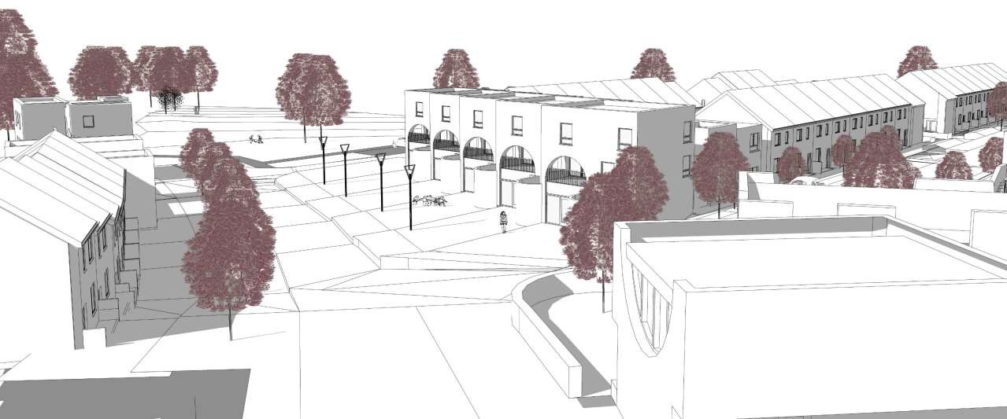
Merlin Woods Mix Tenure Housing Project, In House Design

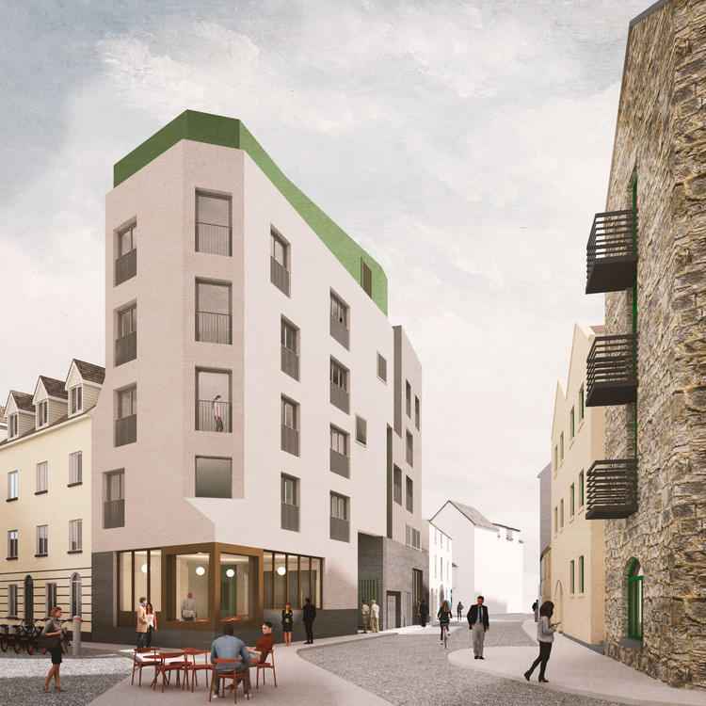

Merchant’s Road, Housing over a Cultural Centre by Hall McKnight

We also collaborate with other departments within the City Council to work other types of projects including the Conservation/Heritage (The Three Castle Project) and Economic Development (Parklets).

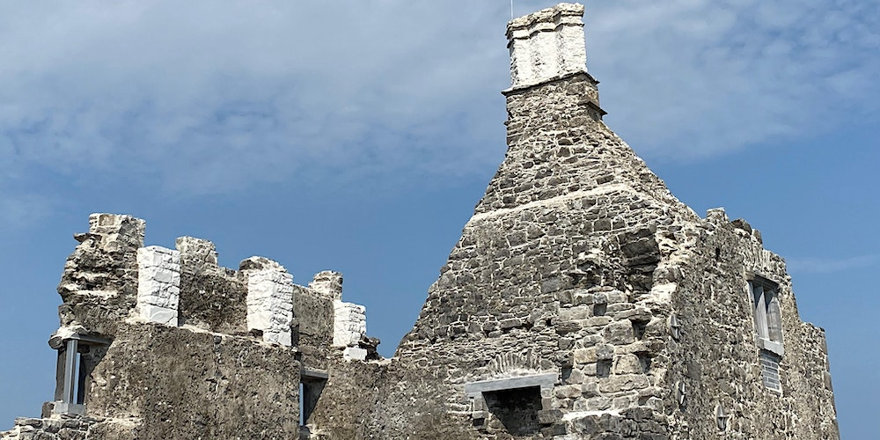
Restoration of Tirellan Castle by 7L Architects

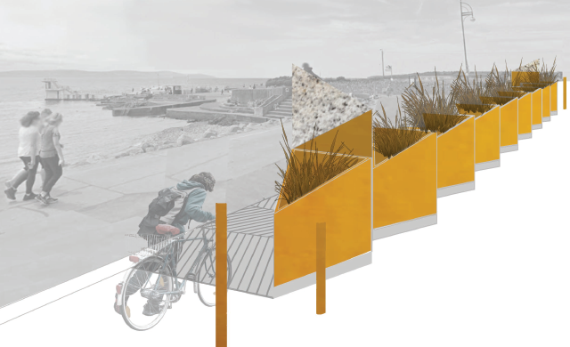
Parklets by A2 Architects

The Galway Charter/Infill Strategy:

A major focus of the Architects Department is the delivery of the NDP’s 50% projected increase of population over the next 20 years, half of which should be on brownfield development. That means that we should be planning housing in the existing footprint of the city for 20,000 people over the next 18 years. The Architects department have led on the discussion of an Infill Strategy which would look at the potential for mapping the city to achieve compact growth. We are currently working with the Academy of Urbanism, RIAI Urban Design Committee and the Irish Cities 2070.

Galway Charter/Irish Cities 2070

A key background for the urban block analysis is the work done to date that sees that the expansion (Urban Sprawl) of Galway is not a sustainable pattern of development. The key role of the work is to make vacancy assessments of every block and to create ‘mini-plans’ to understand the building capacity of the city as a whole. If it is possible to understand the latent existing development potential of the city there is an argument for more focus on brownfield an town centre first developments.

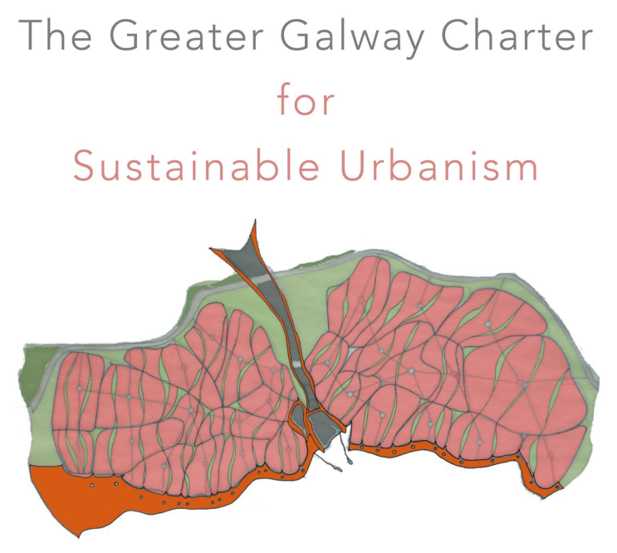

DUTIES AND RESPONSIBILITIES

The key duties and responsibilities of the post of Assistant Architect include, but are not limited to:

- The main duties of the post will be to deliver the Interreg Project.
- Detail Urban Analysis of existing blocks of the City of Galway.
- Have excellent urban analysis skills and methodology.
- Have excellent visual presentations skills
- Report writing and maintaining auditable records of the funding budget.
- Make presentations to other EU partners and public conferences.
- Be willing to travel to other cities in Europe in a timely fashion to fulfil the requirements of the project.
- Be able to progress the workload to completion.
- Be able to work for large sections of time alone on the project.
- The planning, design, procurement and construction of new housing, infrastructure and the maintenance of existing/new housing infrastructure by direct labour and / or by contract;
- The carrying out of regulatory and enforcement duties for the Local Authority;
- The provision of architectural and other advices to the Local Authority;
- The supervision and contract administration and procurement of construction/operations/maintenance schemes;
- The preparation and management of elements of the revenue and capital budgets and ensuring that works are implemented within allocated budgets;
- Ensuring that staff are trained and operate within the relevant skill sets;
- Maintain and proactively develop a culture of Health & Safety in the workplace;
- Ensuring compliance with Health & Safety legislation and regulations, and the Local Authorities Corporate Health & Safety systems;
- Ensuring works are implemented in compliance with all relevant legislation and regulations concerning procurement, planning, etc.;
- Ensuring an efficient and effective response to all stakeholders;
- Carrying out such other duties as may be assigned from time to time.

ESSENTIAL QUALIFICATIONS FOR THE POST

- Character
Candidates shall be of good character.

- Health
Each candidate must be in a state of health such as would indicate a reasonable prospect of ability to render regular and efficient service.

- Citizenship:
Candidates must, by the date of any job offer, be:
- A citizen of the European Economic Area (EEA). The EEA consists of the Member States of the European Union, Iceland, Liechtenstein and Norway; or
- A citizen of the United Kingdom (UK); or
- A citizen of Switzerland pursuant to the agreement between the EU and Switzerland on the free movement of persons; or
- A non-EEA citizen who is a spouse or child of an EEA or UK or Swiss citizen and has a stamp 4 visa; or
- A person awarded international protection under the International Protection Act 2015 or any family member entitled to remain in the State as a result of family reunification and has a stamp 4 visa or
- A non-EEA citizen who is a parent of a dependent child who is a citizen of, and resident in, an EEA member state or the UK or Switzerland and has a stamp 4 visa

- Education, Training, Experience, etc.

Each candidate must, on the latest date for receipt of completed application forms:

- Hold a professional qualification in Architecture that is prescribed under the Building Control Act 2007, or a qualification in Architecture that is equivalent to a qualification so prescribed in Section 14 of the Building Control Act 2007.

AND

- Be eligible for registration as an Architect under the Building Control Act 2007 without requiring further assessment. Any appointment by the employing local authority will be subject to registration under the Act.

AND

- Possess a high standard of technical training and experience

Candidates must:
- Hold a current valid unendorsed driving licence in respect of category B vehicles and must advise if this is not the case. A copy of Licence must be submitted with your application.

*Non-Irish Qualifications must be accompanied by a determination from Quality and Qualifications Ireland (QQI) to establish their comparability against the Irish National Framework of Qualifications, overseas qualifications must also be accompanied by a translation document.

Desirables.
- Has experience of Urban Design Principles or has worked on Masterplanning at a large scale
- Has worked on a European Funded Project
- Has good presentation skills (verbal, drawing, model etc..)
- at least two years satisfactory experience post graduation of architectural work including experience in the design of buildings, preparation of sketch plans, working drawings, technical details, and specifications;
- Have a satisfactory knowledge of public service organisation or the ability to acquire such knowledge;

The Ideal Candidate Shall Demonstrate through their application form and at the interview that he/she has:

- Excellent communication and interpersonal skills
- People management skills
- Budgetary Management Skills
- have strong organisation and IT skills, particularly in graphic presentation and associated CAD skills
- An ability to prepare and present technical reports
- An ability to interpret and undertake critical analysis of scientific data
- Problem solving skills
- possess strong professional knowledge and architectural skills
- have a good working knowledge or demonstrate an ability to acquire a good working knowledge of the legal, regulatory and governance framework within which Galway City Council operates and adhere to corporate policies, protocols and procedures
- have experience of implementing targeted programmes of work and be able to work on their own initiative

Each candidate must include on the application form details of all qualifications obtained by them. The invitation to attend for Interview is not to be regarded as an admission that you possess the prescribed qualifications and/or requirements for this post or are you qualified by law to hold the post. Documentary proof will be required before appointment where you claim credit for particular qualification, experience, etc.

COMPETENCIES FOR THE POST

Key Competencies for the post are given in the table below. Candidates will be expected to demonstrate sufficient evidence within their application form and at interview of competence under each of these headings.
Strategic Management & Change
- Political Awareness
- Has a clear understanding of the political reality and context of the organisation.
- Networking and Representing
- Develops and maintains positive and mutually beneficial relationships with a range of stakeholders.
- Builds networks of technical and professional contacts.
- Promotes and sustains an appropriate, positive, and cohesive image for the organisation it represents.
- Demonstrates a clear understanding of NDP impacts
- Understands Town Centre First Policy
- Understands Climate Change impact of Urbanism

Delivering Results - Delivering Quality Outcomes & Ensuring Compliance
- Problem Solving and Decision Making
- Can pinpoint critical information and address issues logically.
- Understands the context and impact of decisions made.
- Can act decisively in an environment of multiple stakeholders and complex information to ensure decisions are made in line with objectives.
- Delivering Quality Outcomes
- Promotes the achievement of quality outcomes in delivering services.
- Organises the delivery of services to meet or exceed the required standard.
- Evaluates the outcomes achieved, identifies learning and implements improvements required.
- Brings a portfolio of drawings that demonstrates the key communication skills that are required for this post
- Demonstrates urban analysis skills and detailed recording of mythology
- Can show a clear delivery of work in a timely fashion to ensure that they can fulfil the proposed project.
- Intervenes in a timely manner if work activities go over budget.
Performance Through People

- Managing Performance
- Effectively manages performance including managing underperformance or conflict.
- Empowers people to achieve or exceed organisational goals by delegating sufficient authority, responsibility and accountability.
- Communicating Effectively
- Actively listens to others and shares information with relevant stakeholders.
- Has highly effective verbal and written communication skills.
- Presents ideas effectively to individuals and groups.
- Can make good relationships quickly to be able to deliver on the project objectives and goals.
- Have worked in collaboration and alone in urban analysis project.
- Presents ideas effectively to individuals and groups and delivers presentations suited to the nature and needs of the audience.
- Is clear in all communications, considering the audience in getting the message across. Writes fluently, clearly structuring written communication.

Personal Effectiveness
- Relevant Knowledge
- Keeps up to date with current developments, trends and best practice in their area of responsibility.
- Demonstrates the required specialist knowledge, understanding and training for the role.
- Integrity
- Behaves in an honest, trustworthy and respectful manner and is transparent, fair and consistent in dealing with others.
- Personal Motivation, Initiative and Achievement
- Is enthusiastic about the role and is motivated in the face of difficulties and obstacles. Adopts a positive attitude to work. Demonstrates an understanding of the role of Executive Architect in local authority context.
- Initiative and creativity.
- Resilience and Personal well-being.
- Personal Motivation.
- Keeps up to date with current developments, trends and best practice in their area of responsibility.
- Demonstrates a knowledge of current local government issues and advocates practical approaches to addressing them.

PRINCIPAL CONDITIONS OF SERVICE

Type of Post
Galway City Council proposes to create a panel for the position of Assistant Architect from which vacancies will be filled during the lifetime of the panel. Any such panel formed shall be one year in duration. The post is for 2 Years -Specific Purpose Contract and will be temporary, wholetime and pensionable.

Remuneration
The annual salary (Circular Letter EL 03/2024) is as follows:
Point | 01/10/2024
1 | €45,802
2 | €48,444
3 | €50,384
4 | €52,367
5 | €54,397
6 | €56,461
7 | €58,544
8 | €60,627
9 | €62,710
10 | €64,796
11 | €66,894
LSI 1 | €69,038
LSI 2 | €71,185

IMPORTANT NOTE: Candidates should note that the starting salary is not subject to negotiation. Entry into the pay scale above the minimum point will only apply to existing public servants in the context of the relevant Government Pay Circulars. Candidates who are not covered by such Circulars will enter the pay scale at the minimum point i.e. €45,802

The rate of remuneration may be adjusted from time to time in line with Government pay policy.

The holder of the office shall pay to the local authority any fees or other monies (other than their inclusive salary) payable to and received by them by virtue of their office or in respect of services which they are required by or under any enactment to perform.

Probation:
- there shall be a period after such appointments take effect during which such persons shall hold the position on probation,
- such period shall be 12 months but, the Chief Executive may at his or her discretion extend such period,
- such persons shall cease to hold the position at end of the period of probation unless during such period, the Chief Executive has certified that the service of such persons is satisfactory.

Hours of Duty
The person appointed will be required to work a 35 hour week. The successful candidate will be required to log their hours of work in accordance with the requirements of the Organisation of Working Time Act, 1997 and will be required to co-operate with the use of technologies to record such hours.

Annual Leave:
The annual leave entitlement will be 30 days per annum.

Residence:
Holder of the post shall reside in the district in which their duties are to be performed or within a reasonable distance thereof.

Outside Employment:
The position is whole-time and the employee may not engage in private practice or be connected with any outside business which would interfere with the performance of official duties.

Driving Licence:
A full clean driving licence is required. The successful candidate will be required to provide their own transport. Expenses incurred in work related travel will be recompensed in line with departmental circulars.

Garda Vetting:
The successful applicant may be required to undergo Garda Vetting prior to appointment.
Superannuation Contribution:
Persons who become pensionable officers of a local authority, who are liable to pay the Class A rate of PRSI contribution will be required in respect of their superannuation to contribute to the rate of 1.5% of their pensionable remuneration plus 3.5% of net pensionable remuneration (i.e. pensionable remuneration less twice the annual rate of the State Pension Contributory).

Persons who become pensionable officers of a local authority who are liable to pay the Class D rate of PRSI contribution will be required, in respect of their superannuation, to contribute to the local authority at the rate of 5% of their pensionable remuneration.

Widows & Orphans/ Spouses & Children’s Scheme
All persons who become pensionable officers of a local Authority are required, in respect of the Local Government (Spouses and Children’s Contributory Pension) Scheme, 1986, to contribute to the local authority at the rate of 1.5% of net pensionable remuneration (i.e. pensionable remuneration less twice the annual rate of State Pension contributory) in accordance with the terms of the Scheme.

New Entrants From 1st January 2013 – Single Public Services Pension Scheme
FOR NEW ENTRANTS recruited on or after 1st January, 2013 as well as former public servants returning to the public service after a break of more than 26 weeks. The Public Service Pensions (Single Scheme and Other Provisions) Act 2012 applies to your employment. Members of this Scheme are required in respect of superannuation to contribute at the rate of 3% of pensionable remuneration plus 3.5% of net pensionable remuneration (i.e. pensionable remuneration less twice the annual rate of State Pension contributory) and you are liable to pay the Class A rate of PRSI contribution.

Retirement Age:
Retirement age will be determined on previous Public Sector Service (if any) and will be advised on appointment.

Former Public Service Employees
Eligibility to compete may be affected where applicants were formerly employed by the Irish Public Service and previously availed of an Irish Public Service Scheme including:
- Incentivised Scheme for Early Retirement (ISER)
- Department of Health and Children Circular (7/2010)
- Collective Agreement: Redundancy Payments to Public Servants

Applicants should ensure that they are not precluded from re-engagement in the Irish Public Service under the terms of such Schemes. This is a non-exhaustive list and any queries should be directed to the applicant’s former Irish Public Service Employer in the first instance.

Declaration
Applicants will be required to declare whether they have previously availed of a public service scheme of incentivised early retirement and/or the collective agreement outlined above. Applicants will also be required to declare any entitlements to a Public Service pension benefit (in payment or preserved) from any other Public Service employment and/or where they have received a payment-in-lieu in respect of service in any Public Service employment.

Offer of Appointment
Galway City Council shall require persons to whom an appointment is offered to take up such appointment within a period of not more than one month from the date on which the offer is made. If they fail to take up the appointment within such period, or such longer period as the Council in its absolute discretion may determine, the Council shall not appoint them.

All appointments are subject to receipt of satisfactory references and candidates may be required to produce documentary evidence of qualifications or experience claimed in their applications.

FORMAT OF THE COMPETITION

Applications must be made on the official application forms and all sections must be completed in full. When completing the application form accuracy is essential as it will be used as a computer input document. The information you supply in the application form will play a central part of the short listing process. Galway City Council’s decision to include you on the shortlist of candidates going forward to stage two of the process may be determined based on this information.

Where, by reason of the number of persons seeking admission to the competition and the standard of knowledge, training or experience in general of such persons, Galway City Council consider that it would be reasonable not to admit all the persons to the competition, Galway City Council may admit to the competition only persons who appear likely to them to attain in the competition a standard sufficient for selection and recommendation for appointment.

The admission of a person to a competition, or invitation to attend an interview, is not to be taken as implying that Galway City Council are satisfied that such person fulfils the requirements of the Regulations or is not disqualified by law from holding the position and does not carry a guarantee that your application will receive further consideration. It is important therefore, for you to note the onus is on you to ensure that you meet the eligibility requirements for the competition before attending for interview. If you do not meet these essential entry requirements but nevertheless attend for interview you will be putting yourself to unnecessary expense, as Galway City Council will not be responsible for refunding any expenses incurred.

The competition may consist of a two-stage process:
- Short-listing (Desktop and/or Interview)
- Competitive interview

Galway City Council may at their discretion require candidates to attend a preliminary interview in which case admission to the competitive interview would be conditional on candidates reaching such a standard as Galway City Council considered appropriate in the preliminary interview.

Interviews shall be conducted by Board(s) set up by Galway City Council. The Board(s) will assess the merits of candidates (except insofar as they are assessed otherwise) in respect of matters referred to in the prescribed Qualifications and any other relevant matters.

Before being recommended for appointment candidates shall satisfy Galway City Council that they possess the requisite knowledge and ability (including a high standard of suitability and where administrative experience is a requirement, that the candidate possess experience at an appropriate level) for the proper discharge of the duties of the position. Galway City Council may, at their discretion, select and recommend another person(s) for appointment on the results of this competition if the person recommended for appointment does not accept the appointment or, having accepted it, relinquishes it or if an additional vacancy arises.

The onus is on all applicants to make themselves available for the obligatory test(s) on the date(s) specified by Galway City Council and to make whatever arrangements are necessary to ensure that they receive communications sent to them at the address specified on their application form.

Galway City Council reserves the right to conduct interviews (Shortlisting and/or Final Interviews) through a virtual platform i.e. Microsoft Teams.

GENERAL INFORMATION
Galway City Council will not be responsible for any expense, including travelling expenses, candidates may occur in connection with their candidature.
Closing Date:
The completed application form must be posted/delivered/emailed so as to reach the Human Resources Department, Galway City Council, City Hall, College Road, Galway, not later than 4.00pm on Friday, 10 January 2025. Claims that any application form or letter relating to it has been lost or delayed in the post will not be considered unless a Post Office Certificate of posting is produced in support of such claims. The responsibility to make contact with An Post regarding any delays rests with the applicant.
Deeming of Candidates to be Withdrawn:
Candidates who do not attend for interview or other test when and where required by Galway City Council, or who do not, when requested, furnish such evidence as Galway City Council require in regard to any matter relevant to their candidature, will have no further claim to consideration.

Appeals
Galway City Council will consider appeals in relation to eligibility and shortlisting decisions. Such appeals must be made by candidates in writing within 5 working days of notification of the relevant decision. On receipt of appeal, the selection decisions will be re-visited and the candidate will be informed of the outcome of this review.

Data Protection Acts 1988 – 2018 and General Data Protection Regulation:
When your application form is received, we create a computer record in your name, which contains much of the personal information you have supplied. Should your name come under consideration for a post, a manual file will then be created. The personal records are used solely in processing your candidature. Such information held on computer is subject to the rights and obligations set out in the General Data Protection Regulations.

Sharing Information: Outside of the relevant recruitment team, the information provided in your application form (i.e. Section 1 & Section 2) will only be shared for progressing the competition for which you have applied for, with a designated short‐listing and/or interview board.

Confidentiality:
Subject to the provisions of the Freedom of Information Act, 1997 and 2003; applications will be treated in strict confidence.

Galway City Council is an equal opportunities employer.

Canvassing will automatically disqualify.

NOTE: PLEASE RETURN ONLY THE APPLICATION FORM AND RETAIN THE INFORMATION BOOKLET FOR YOUR OWN RECORDS.

