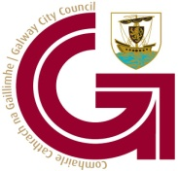

Galway City Council

Comhairle Cathrach na Gaillimhe

Staff Vacancy – Confined Competition

ACTING ADMINISTRATIVE OFFICER

(Confined Competition)

Galway City Council is pleased to invite suitably qualified applicants for above position.

Application forms and full particulars for the above post may be obtained from the Human Resources Department, City Hall, College Road, Galway. Applications may be shortlisted on the basis of the information provided on the application form.

The closing date for receipt of fully completed application forms for this position is no later than 4.00pm Monday 3rd October 2022. All fully completed application forms must reach the Human Resources Department by this date.

It is intended to hold the interviews shortly after the closing date.

Tel. No. (091) 536596 Email: hr@galwaycity.ie Website: www.galwaycity.ie

Signed: R, McNally, Director of Services, Human Resources.

Galway City Council is an equal opportunities employer

