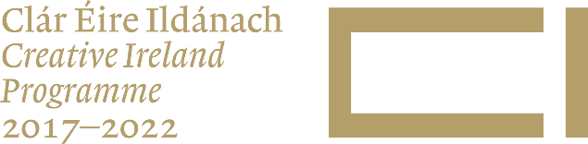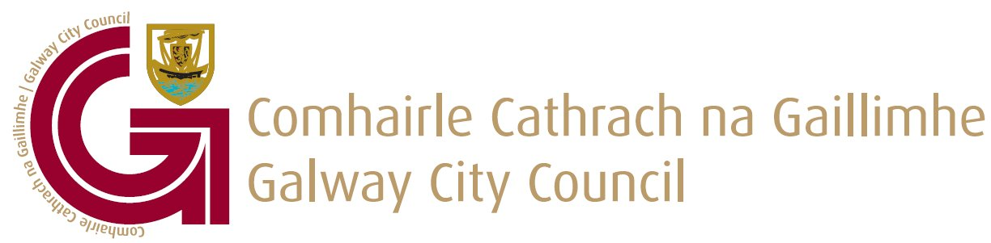

Galway City Council
Creative Ireland Funding 2021

GUIDELINES FOR APPLICATNTS

As part of the Creative Ireland Programme 2021, Galway City Council invites applications for funding for our Creative Ireland Programme Projects.
There are two Categories of funding available which are detailed below:-

Category 1:
Development of Community or public Creative Micro Spaces. Small scale works to enable greater engagement of communities with creativity.

Category 2:
- Creative Community Projects that focus on Engagement of new audiences/communities.
- European mobility projects.
- Build on Galway’s unique bi-lingual status to strengthen the use of the Irish language in Galway.

The vision of Creative Ireland is that every person living in Ireland will have the opportunity to fully realise their creative potential. This vision is pursued through the Five Pillars of the Creative Ireland Programme.

Pillar 1: Enabling the Creative Potential of Every Child
Pillar 2: Enabling creativity in Every Community
Pillar 3: Investing in our Creative and Cultural infrastructure
Pillar 4: The Creative Industries: Ireland as a Centre of Excellence in Media Production
Pillar 5: Unifying our Global Reputation

Galway is a vibrant, diverse city. It is a city of learning, a city of youth, a city of rich cultural heritage and of stunning natural environment. Galway is a creative city where everybody matters. Galway City Council aims to position Galway as a world-class city of innovation and creativity. We want to create a city that people aspire to live in, to work in and to visit. The Galway City Creative Ireland Strategic Plan guides our vision for Galway City.
The priority set out for 2021 Creative Ireland funding call is specifically around the 2 categories identified above and all applications must demonstrate delivery of projects from Category 1 or 2 or both categories.
Projects must reflect one or more of the 8 strategic objectives identified in the Galway City Creative Ireland Strategic Plan 2018-2022; see below:

Creative Micro Spaces
To Revitalise and regenerate our public spaces and to improve the connectivity of communities to the built environment and public spaces.
European mobility projects
Identify and support European mobility projects, international residencies, access to areas of artistic excellence and curatorial exchange programmes for artist and cultural workers.
Pairing Artists/Creatives with industry/multi-national
Increase the practice of pairing artists/creative’s with industry/multi-national campuses to promote the benefits of collaborative practice.
Participation in international cooperation networks
Develop policies and programmes that allow people active in Galway’s cultural sector, to participate in international cooperation networks.
Improve engagement
Improve engagement with the public through more open and effective consultation processes.
Irish language in Galway
Build on Galway’s unique bi-lingual status to strengthen the use of the Irish language in Galway.
Health & Wellbeing
Develop, with the creative sector, capacity building programmes, for social services and other health workers that improves health and well-being among staff and service users. Develop, on a pilot basis, on directed health and culture initiative, with the local and national HSE.
Grassroots Cultural Processes and social innovation
Develop policies that guarantee access to free and plural information, as well as measures to guarantee that information is harnessed to promote citizen ‘rights to participate in cultural life’. Implement a system that ensures that relationship and outcome between grassroots cultural processes and social innovation is analysed regularly.
Application Process

The application window for this Creative Ireland funding opens on 30th of July 2021 and closes at 4pm 20th August 2021.
Applications can only be submitted using the Galway City Council Creative Ireland Application Form which can be downloaded from the www.galwaycity.ie/creativeireland2021

Shortlisting

Once the application deadline closes all submissions will be assessed against the following set of criteria:
- All applications must demonstrate delivery against objectives set out in Category 1 or 2, or both categories.
- Only 1 grant will be awarded per group/organisation
- Priority in Category 1 will be given to the creation of micro creativity spaces in non-mainstream cultural buildings(public spaces/community facilities/public offices/shopping centres)
- Creativity space must be accessible to the public free of charge.
- The extent of which proposals meet the objectives outlined above.
- Proven capacity of the applicant group to develop and deliver the proposed project.
- Proven expertise and experience of the creative/cultural practitioners engaged with the applicant group.
- Budget feasibility – budgets must be realistic and proposed activities deliverable within the budget. While match funding is not a requisite for applicants we will welcome proposals that have secured some match funding.
- Projects seeking funding through this submission cannot be in receipt any other public funding for the proposed project/programme.

All projects are required to be completed with all documentation submitted by
12th November 2021.
The amount awarded to any one project will typically be between €1,000 and €5,000, Galway City Council may consider amounts in excess of €5,000 for projects that deliver on multiple objectives. The quantity and value of awards will depend on available funding, number of applicants and the quality of applications.

Notes to Applicants

Applicant bodies must be a legal entity with their own bank account and tax clearance certification.
Shortlisted projects will be required to provide evidence of appropriate insurances and also to indemnify Galway City Council.
Shortlisted projects will be required to adhere to Galway City Council’s Communications and Branding Guidelines as well as Branding associated with the Creative Ireland Programme.
Shortlisted projects will be required to adhere to Galway City Council’s policies in the area of accessibility, diversity and inclusion to ensure that project events and activities are as inclusive and accessible as possible.
All projects supported under Creative Ireland 2021 funding must be fully completed by 12th November 2021

All Creative Ireland queries please email c&c@galwaycity.ie with subject line
Creative Ireland Funding Call 2021

