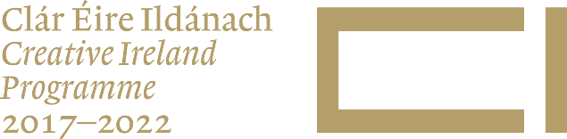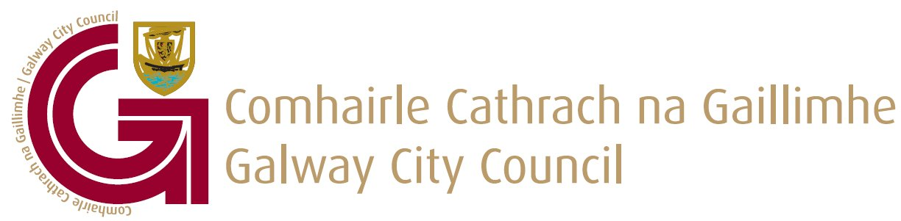

Galway City Council
Creative Ireland Funding 2021

There are two Categories of funding available which are detailed below:-

Category 1:
Development of Community or public Creative Micro Spaces. Small scale works to enable greater engagement of communities with creativity.

Category 2:
- Creative Community Projects that focus on Engagement of new audiences/communities.
- European mobility projects.
- Build on Galway’s unique bi-lingual status to strengthen the use of the Irish language in Galway.

It is important that you tick the correct Category when beginning the application form.

Category 1: ם | Category 2: (please tick the appropriate box/boxes)  a. ם  b. ם  c. ם
Please give the name of your organisation.

Please provide the contact details for your organisation.

Contact Person-

Contact Address-

Contact email –

Contact Telephone Number -

What level of funding are you seeking for your project?

What is the estimated total cost of your project?

Where there match funding in place for this project please indicate the amount of this match funding.

What is the name of the project?

Project description:
Describe your proposed project in no more than 300 words.

Project Objectives: Please tick (up to a max of 3) which of the objective/objectives your project delivers on:-

Creative Micro Spaces ם
To Revitalise and regenerate our public spaces and to improve the connectivity of communities to the built environment and public spaces.
European mobility projects ם
Identify and support European mobility projects, international residencies, access to areas of artistic excellence and curatorial exchange programmes for artist and cultural workers.
Pairing Artists/Creatives with industry/multi-national ם
Increase the practice of pairing artists/creative’s with industry/multi-national campuses to promote the benefits of collaborative practice.
Participation in international cooperation networks ם
Develop policies and programmes that allow people active in Galway’s cultural sector, to participate in international cooperation networks.
Improve engagement ם
Improve engagement with the public through more open and effective consultation processes.
Irish language in Galway ם
Build on Galway’s unique bi-lingual status to strengthen the use of the Irish language in Galway.
Health & Wellbeing ם
Develop, with the creative sector, capacity building programmes, for social services and other health workers that improves health and well-being among staff and service users. Develop, on a pilot basis, on directed health and culture initiative, with the local and national HSE.
Grassroots Cultural Processes and social innovation ם
Develop policies that guarantee access to free and plural information, as well as measures to guarantee that information is harnessed to promote citizen ‘rights to participate in cultural life’. Implement a system that ensures that relationship and outcome between grassroots cultural processes and social innovation is analysed regularly.

Outline how this initiative meets the stated objective/objectives of the Creative Ireland Strategy. (300 words)

Where will the initiative be located/delivered? (Please give specific details of - venues/buildings/housing estates/communities/etc.)

When will the initiative take place? (All projects are required to be completed with all documentation submitted by 12th November 2021.)

Engagement with Artists and Cultural Practitioners:
Please list names of artists and/or cultural practitioners that will be directly involved in the project

Expenditure:
Please detail how the funding will be spent:

Statement Confirming Adherence to Guidelines-

I, (Name) on behalf of (Organisation) confirm that our proposal submitted will meet the guidelines and criteria if the Galway City Council Creative Ireland Fund 2021.

Signed _____________________________________ Date __________________

Checklist

- Evidence of required permissions from property/venue owner for all proposed activities.

- Evidence of Public Liability Insurance in place.

- Evidence of any match funding in place. (if required for this proposal)

- Evidence of required breakdown of costs for project delivery.

- Conformation that the project proposed is not in receipt of any other public funding.

