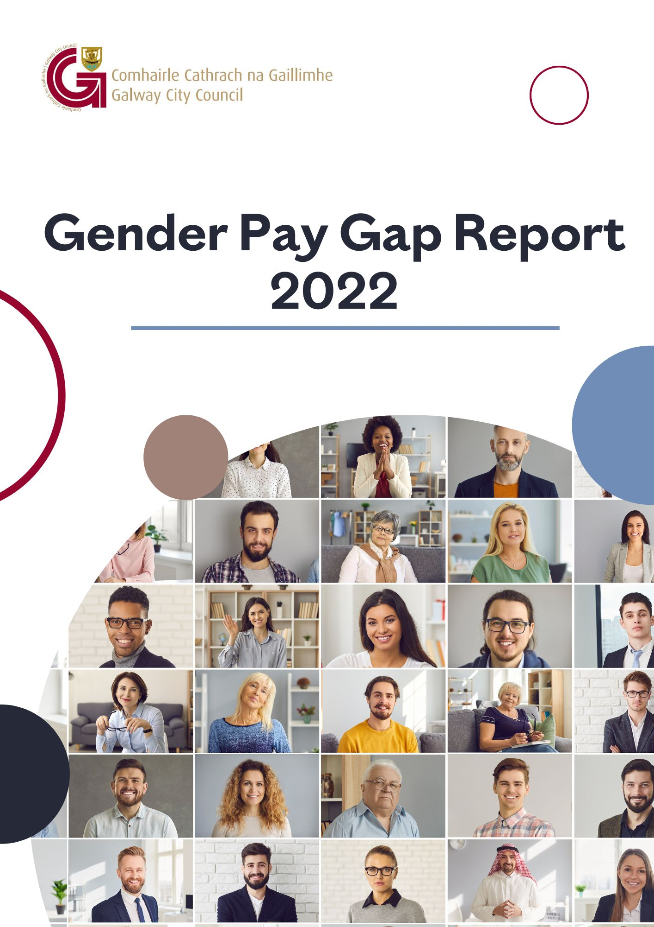

Contents

1. Introduction 1
2. About Us 2
2.1 Local Government in Ireland 2
2.2 Galway City Council 4
3. Gender Pay Gap Reporting 5
3.1 Gender Pay Gap Reporting 2022 5
3.2 Who is Included? 5
3.3 What do we mean by the Gender Pay Gap? 5
3.4 Mean and Median Gender Pay Gap 6
3.5 Quartile Pay Bands 7
3.6 Bonus and Benefit-in-Kind 7
3.7 Factors that can have an Impact on the Gender Pay Gap 8
4. Our Figures 9
4.1 Mean and Median Gender Pay Gap and Pay Band Quartiles– All Employees 9
4.2 Mean and Median Gender Pay Gap – Part-Time Employees 11
4.3 Mean and Median Gender Pay Gap – Temporary Employees 12
5. Other Payments 12
5.1 Benefit in Kind 12
5.2 Bonus payment 12
6. How we are Supporting Gender Equality 13
6.1 Fair and Transparent Recruitment Practices 13
6.2 Work life Balance 13
6.3 Blended Working 13
6.4 Learning and Development 14
6.5 Health and Wellbeing 14
6.6 Dignity at Work 14
6.7 Equality, Diversity and Inclusion 14
6.8 Public Sector Duty 15
6.9 Women in Leadership 15
6.10 Apprenticeships 15
6.11 Data Collection and Evidence-Based Policy Development 16

Introduction
I am pleased to introduce Galway City Council’s first gender pay gap report. This report fulfils our obligations under The Gender Pay Gap Information Act of 2021, introduced on a legislative basis for gender pay gap reporting in Ireland.
Galway City Council is a place where all employees have the same opportunities for recognition and career development and are treated fairly and equitably at work. We are committed to ensuring equality of opportunity, supporting diversity and creating an open and inclusive workplace community.
This report provides us with vital statistical information and helps us to understand where pay gaps exist and why. Our review of our gender pay gap results will be systematic, we will identify the actions needed to address any issues highlighted by this report. We will also use the opportunity to examine what the report tells us about our organisation, what we need to incorporate in our future workforce planning processes and how it can support us in our ambition to become an employer of choice.
We will work with our colleagues across the local authority sector to share best practice based on the learnings from this report. We are committed to ensuring we attract, retain, and develop the necessary talent to support us with the delivery of services to Galway City, in an ever-changing public service landscape.
I wish to thank all my colleagues and the group of public service unions for their support of our efforts to ensure Galway City Council remains an employer that offers equality of opportunity for all.

Brendan McGrath.
Chief Executive.
Galway City Council.

About Us

Local Government in Ireland
There are 31 local authorities and 3 regional assemblies in Ireland. Local authorities are the closest and most accessible form of government to citizens. They have responsibility for the delivery of a wide range of services in their local area, with a focus on making cities, towns, villages and the countryside attractive places in which to live, work and invest.
Local authority services make a significant contribution to the physical, cultural, social and environmental development of communities and include housing, planning, infrastructure, environmental protection and the provision of amenities and recreation and community infrastructure.
Local authorities play a key role in promoting social inclusion and quality of life and supporting economic development and enterprise at a local level. Local authorities take the lead role in shaping the strategic vision of the county or city. They also work in partnership with other state, public and private bodies in the delivery of critical infrastructure and shared services.
Local authorities deliver hundreds of services and implement policy across a range of areas including:
- Arts and culture
- Climate action
- Community services
- Economic development
- Environment
- Housing
- Libraries
- Parks and open spaces
- Planning
- Roads and transport
- Tourism

Local authority employees come from a wide range of backgrounds with diverse skill sets, qualifications and experience. Roles in the sector include:
- Accountants
- Administrators
- Apprenticeships
- Archaeologists
- Architects
- Archivists
- Conservation officers
- Engineers
- Fire services
- General service and tradespeople
- Graduates
- Health and Safety
- Information technology
- Library services
- Planners
- Senior management roles
- Technicians

Working for Galway City Council gives our employees the opportunity to gain experience at the heart of local government and to make a real difference for Galway City. Everything we do in Galway City Council is geared towards making Galway City a great place to live and work and our employees play a vital role in that ambition.

Galway City Council
Galway City’s reputation precedes it as a culturally diverse, vibrant, youthful city, surrounded by the breath-taking vistas of Connemara to the west, Lough Corrib to the north and the wildness of the Atlantic Ocean rearing at the south of the city. Many factors contribute to make Galway City a unique place to live, work and visit.
Galway City Council employs a workforce of approximately 550 employees. As an organisation, Galway City Council seeks to enhance the city’s attraction as a place in which to invest, work, and live, and takes the lead role in shaping the strategic vision of the city. We provide a diverse, multi-layered and evolving range of services to both citizens and visitors to Galway City, which include the provision of housing, planning, development, environmental, roads, traffic, leisure and community services.
Our employees work in a dynamic and progressive local authority which promotes equal opportunities for all. They are our most valuable resource.
Galway City Council workforce breakdown is as follows:

Gender Pay Gap Reporting

Gender Pay Gap Reporting 2022
The Gender Pay Gap Information Act, 2021 requires organisations with over 250 employees to report on their Gender Pay Gap. 2022 is the first year that organisations will have to report on their Gender Pay Gap.
Organisations are asked to select a ‘snapshot’ date in the month of June. The reporting period is the 12-month period immediately preceding and including the snapshot date, which for local authorities, is June 30th, 2022. Organisations have six months to prepare their calculations, before reporting six months later during December 2022. The information must be published on the employer’s website or in some other way that is accessible to all its employees and to the public.

Who is Included?
All persons employed by the employer on the snapshot date, including employees not rostered to work on that date and employees on leave. The mean and median figures must also be given separately for part-time and temporary employees.

What do we mean by the Gender Pay Gap?
The Gender Pay Gap calculates the percentage difference between the average earnings of males and females irrespective of their role.
The Gender Pay Gap is not the same as equal pay. Employment Equality legislation provides for equal pay for like work. All male and female employees in the local government sector are paid equally for work that is the same or similar or for work of equal value, therefore this report does not examine equal pay. Rates of pay within the sector are agreed through national wage agreements negotiated regularly between employers and staff representatives. Most employees are paid according to an incremental salary scale and the salary ranges for various roles are available on the local government jobs website at www.localgovernmentjobs.ie

Mean and Median Gender Pay Gap
The Gender Pay Gap is calculated, using the following measures:
MEAN GENDER PAY GAP
This shows the % difference between the
average hourly rate of pay for males
and
average hourly rate of pay for females
(average male hourly rate) – (average female hourly rate) x 100
average male hourly rate
MEDIAN GENDER PAY GAP
This shows the % difference between the
median hourly rate of pay for males
and
median hourly rate of pay for females
(median of male hourly rates) – (median of female hourly rates) x 100 median of male hourly rates

The mean is the average. It is calculated by getting the difference between the average hourly rate of pay for males and the average hourly rate of pay for females (male hourly rate minus female hourly rate), expressed as a percentage of the male hourly rate. If this figure is negative, the average hourly rate of females is higher than the average hourly rate of males on the snapshot date. If this figure is positive, the average hourly rate of males is higher than the average hourly rate of females on the snapshot date
The median is the figure that falls in the middle of a range where the salary of all relevant employees is listed, from the lowest to the highest. This can provide a more accurate representation of the ‘typical’ differences in pay.
It is useful to look at both the mean and median figures, as each one can tell us something different about the underlying factors affecting the pay gap. For example, a small number of higher paid employees can impact the mean figure and if this is the case, the median figure may be more representative of difference between what a male and a female is paid.
If there is a significant difference between an organisation’s mean and median pay gap, this may indicate that the data is impacted either by the presence of low earners (making the mean lower than the median) or by a group of higher earners (making the mean higher than the median).
It is also important to remember that this report uses data on a snapshot date in June. Gender pay gaps can fluctuate from month to month and across quartile pay bands, depending on changes to headcount. However, headline figures will give a good indication of the differences between average earnings between males and females.

Quartile Pay Bands
Dividing employees into four more-or-less equal groups (or quartiles) with pay graded from lowest to highest helps us to examine pay across different levels of the organisation. Organisations must report on the percentage of employees who fall within the lower, lower middle, upper middle and upper quartile hourly pay bands.
In order to group employees into these Quartile Pay Bands, the organisation lists all employees from lowest to highest, based on their hourly rates. The employees are then divided into four equal groups or Quartiles based on this - lower, lower middle, upper middle and upper. The employer then shows the proportion of male and female employees in each quartile as a percentage e.g., percentage of male employees in the lower quartile and percentage of female employees in the lower quartile (and so on).

Bonus and Benefit-in-Kind
Figures must also be provided for bonus payments or benefit-in-kind payments if these apply. Bonus payments do not apply within the local government sector.
Benefit in Kind may arise in certain circumstances, such as where some professional fees are paid by the employer.

Factors that can have an Impact on the Gender Pay Gap
As mentioned, this report does not look at equal pay. Every employee, regardless of gender is paid equally for work that is the same or similar or for work of equal value. However, differences between what employees are paid can be impacted by a number of complex factors including:
- Occupational segregation – some job categories or occupations may have traditionally attracted more females than males or vice versa.
- Working patterns – full-time and part-time work. It may be that more females than males seek part-time work or career breaks and although this does not impact on their hourly rate of pay, it may impact on choices around career progression.
- Length of service – incremental pay increases may mean that new joiners are paid less than more experienced employees.
- Time of year – temporary or seasonal workers may be recruited for different roles which may attract a different rate of pay.
- Gender breakdown of senior roles at higher salaries – a small number of higher paid employees can affect the average figures.
- Gender breakdown of lower paid roles – a large number of lower paid employees can affect the average figures.

If an organisation reports a positive gender pay gap, it does not mean that females are paid less than males for doing the same job, but it does show that, on average, males occupy higher paid roles than females.
If an organisation reports a negative gender pay gap, it does not mean that males are paid less than females for doing the same job, but it does indicate that, on average, females occupy higher paid roles than males.
The larger the positive or negative pay gap is, the more marked the differences in hourly rates of pay will be and the more males or females proportionally working in either higher or lower paid roles within the organisation.

Our Figures

Mean and Median Gender Pay Gap and Pay Band Quartiles– All Employees
Galway City Council Gender Pay Gap 2022
All employees for the reporting period to 30 June 2022
MEAN GENDER PAY GAP | MEDIAN GENDER PAY GAP
-7.01% | -14.51%

Note: 60%/40% is the gender breakdown of all employees on 30 June 2022. This is shown in the dotted line above
The Mean Gender Pay Gap shows that on average, the mean rate of pay for females is 7% higher than the mean rate of pay for males.
The Median Gender Pay Gap shows that the median rate of pay for females is 14% higher than the median rate of pay for males.

Looking at the distribution of employees across the four Quartile Pay Bands helps us to examine pay at different levels of the organisation.
These Quartile Pay Bands show the distribution of male and female employees by Pay Band across the organisation (the organisation lists all employees from lowest to highest, based on their hourly rates, then divides this into four equal Pay Bands or Quartiles - lower, lower middle, upper middle and upper. The employer then shows the proportion of male and female employees in each quartile).
The split for each of the 4 Quartiles shown above varies by Pay Band, as follows:
Pay Band 1 comprises of approximately 65% Male / 35% Female. Pay Band 2 comprises of approximately 74% Male / 26% Female. There is a higher proportion of males in Band 1 and Band 2, reflecting that there are proportionately more males at lower grades which influences the overall Mean and Median Gender Pay Gap results in favour of females.
In Bands 3 and 4 we see a closer Male /Female split with 57% Male / 43% Female in Band 3. Band 4 comprises of approximately 51% Male / 49% Female.
For there to be no Gender Pay Gap you would expect to see the workforce demographics reflected more closely in each quartile.
More males in the lower grades and fewer females at higher grades can affect the mean and median pay gaps.

Mean and Median Gender Pay Gap – Part-Time Employees
Galway City Council Gender Pay Gap 2022
Part-time employees for the reporting period to 30 June 2022
MEAN GENDER PAY GAP | MEDIAN GENDER PAY GAP
-30.46% | -18.34%

Approximately 14% of all our employees on 30 June 2022 were working part-time. Of these, 20% were Male and 80% were Female.
Factors influencing the pattern of part-time employees across the organisation include a range of flexible work options for part-time work, which, while available to all employees, have a greater up-take by female employees. Another factor is job categories where part-time work is an occupational feature of the role, for example school wardens.
In the case of Galway City Council, the higher negative gender pay gap for the part-time mean and median hourly rate is explained by the higher proportion of females availing of part-time work in Pay Bands 3 and 4. There are 0% males working part-time in Pay Band 4 and only 4% of males working part-time in Pay Band 3.

Mean and Median Gender Pay Gap – Temporary Employees

Galway City Council Gender pay gap 2022
Temporary employees for the reporting period to 30 June 2022
MEAN GENDER PAY GAP | MEDIAN GENDER PAY GAP
-2.82% | 0.58%

On 30 June 2022, 10% of our employees were employed on temporary contracts.
Of these, 47% were female and 53% were male. These contracts include temporary/seasonal employees such as school wardens, general operatives, graduates, technicians and engineers.
It is useful to look at the pay distribution of Temporary employees which reflect the closest Mean and Median Gender Pay Gaps.

Other Payments

Benefit in Kind
On 30 June 2022 no employees were in receipt of Benefit in Kind over the previous twelve-month period.

Bonus payment
Bonus payments do not feature as part of pay in the local government sector.

How we are Supporting Gender Equality
In accordance with the Gender Pay Gap Information Act 2021, 2022 is the first year that Galway City Council has reported on the gender pay gap. Equality, diversity and inclusion continue to be part of the way we work.

Fair and Transparent Recruitment Practices
- As an equal opportunity’s employer, we work to promote a culture of equality. We strive to embrace equality of opportunity through our recruitment and selection processes which are open to all.
- We provide appropriate assistance and accommodation throughout our recruitment and selection processes, including providing easily accessible interview facilities, agreeing an appropriately timed interview, and supplying or arranging appropriate equipment.
- All our Interview Boards are gender balanced.
- Recruitment websites highlight family friendly and flexible working options, and our job descriptions and job advertisements are gender neutral.
- We provide training and support, open to all employees to help them prepare for job applications and interviews.
- Employees are paid according to an incremental salary scale, and we offer strong career progression opportunities which are open to all employees.

Work life Balance
We offer a wide range of flexible working and leave options which are available to all employees, including flexi-time, carer’s leave, career breaks, paid maternity and adoptive leave, paid paternity leave, parent’s leave, parental leave, shorter working year scheme and work-sharing.

Blended Working
Blended working is now a part of our flexible working policies with options to combine office and home/hub working.

Learning and Development
We are committed to providing ongoing learning and development opportunities so that all employees can develop to their full potential. All employees are actively encouraged to pursue education opportunities through our Training and Development Policy and Procedure, with study and examination leave also available.

Health and Wellbeing
The health and wellbeing of all employees is paramount, and a healthy work-life balance is important to us. We offer comprehensive employee occupational health and wellbeing programmes including an Employee Assistance Programme, health screening, vaccinations, health and nutrition advice and wellbeing webinars etc.

Dignity at Work
We promote and support a culture of dignity, respect and equality. We have a Dignity at Work Policy, and all employees and managers receive training and support in the implementation of the policy.

Equality, Diversity and Inclusion
- Our aim is to continually develop as an employer of choice and to attract, develop and promote an inclusive and diverse employee population.
- We continue to design and provide responsive services and customer care that meet the needs of an increasingly diverse customer base.
- An assessment has been conducted on equality and human rights across all Council functions and services and the Council has developed an Action Plan on equality and human rights.
- Human rights and equality statement has been incorporated into the Council’s corporate and strategic plans.

Public Sector Duty
- We progressively embed the Public Sector Duty in our current management, policy development and service delivery processes.
- The Public Sector Duty is set out in Section 42 of the Irish Human Rights and Equality Commission Act, 2014. Section 42 requires a public body, in the performance of its functions, to have regard to the need to eliminate discrimination, promote equality of opportunity and treatment of its staff and the persons to whom it provides services and protect human rights of its members, staff and the persons to whom it provides services.
- Public bodies are required to set out in a manner that is accessible to the public in its strategic plan an assessment of the human rights and equality issues it believes to be relevant to its functions and purpose and the existing or proposed policies, plans and actions to address those issues.
- We acknowledge the commonality of purpose stated in both the Public Sector Duty and Gender Pay Gap reporting requirements and the publication of this report serves to underline and support the three-step approach advocated by the Irish Human Rights and Equality Commission i.e., Assess, Address and Report.

Women in Leadership
Our Senior Management Team comprises the following gender balance 50% Male and 50% Female and we aim to work on developing Women in Leadership programmes.

Apprenticeships
As part of our inclusive approach to recruitment, Galway City Council plans to offer a number of apprenticeship programmes and participates as part of the Department of Further and Higher Education, Innovation and Science’s Action Plan for Apprenticeship 2021 – 2025 which aims to increase the number of apprenticeships within the Public Service. This includes new apprenticeship programmes linked to areas of work within local authorities, including IT and Finance as well as more traditional apprenticeship areas.

Data Collection and Evidence-Based Policy Development
We welcome the opportunity to report on our gender pay gap and have worked collaboratively across the sector to provide a standard and consistent approach to reporting. We will work with the Local Government Management Agency and our colleagues in other local authorities to share learnings and best practice.



