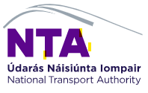
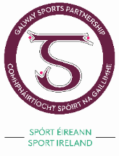
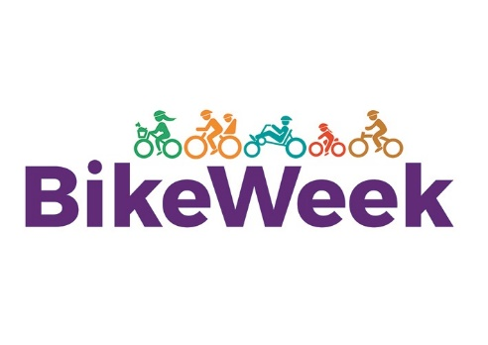
Galway Bike Week: Sun 12th – Sat 18th Sept
Contact Details
Name of organisation: ______________________ Name of contact person:_____________________________
Address:________________________________ Contact number(s):_________________________________
Email address:_____________________________________________________________________________
The Proposed Event
Name of the Event:___________________________________________________
Date, Time & Duration of Event:________________________________________
Location: __________________________________________________________
Description of your Proposed Event (if successful this may be used for promotional material)
_________________________________________________________________________________________
_________________________________________________________________________________________
_________________________________________________________________________________________
_________________________________________________________________________________________
_________________________________________________________________________________________
Promoting your Event
How do you plan to promote the event, what is the target market and the estimated level of participation? _________________________________________________________________________________________
_________________________________________________________________________________________
_________________________________________________________________________________________
_________________________________________________________________________________________
Event Costs
How much will the event cost? ________________ How much funding is applied for? ________________

Certification

I certify that all the details supplied in this application form are true and correct to the best of my knowledge and that the application has been submitted with full knowledge and agreement of the management of the applicant organisation. I have read the Terms and Conditions.

I agree to indemnify and to keep indemnified and to hold harmless Galway City Council, Galway County Council, the Minister and Department of Transport, Tourism and Sport its servants and agents and each of them from and against all actions, costs, claims, charges, expenses and damages whatsoever which may be brought or made or claimed against the Councils, the Minister and Department of Transport, Tourism and Sport arising out of or in relation to the holding of the above mentioned event. I agree on behalf of the organisers to accredit Galway Bike Festival and National Bike Week in all promotional materials.

Signature of contact person: __________________________________________
Name of contact person: __________________________________________ Date: __________________________________________

The details given here in relation to your organisation may be shared with other Departments within Galway City Council and Galway County Council. It will not be made available to other agencies. If you do not wish to have your contact details shared please tick here.

Please return completed forms by Friday 29th July 2021, at 4:00pm

Galway Transportation Unit, Galway City Council, City Hall, College Road, Galway
or by email to gtu@galwaycity.ie

