Galway Bike Week-Sat 14 to Sun 22 May 2022
Application Form
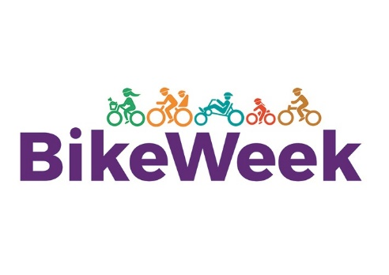
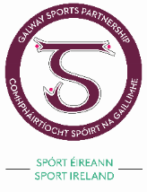
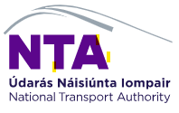

Contact Details

Name of organisation: ______________________ Name of contact person:_____________________________
Address:________________________________ Contact number(s):_________________________________
Email address:_____________________________________________________________________________
The Proposed Event

Name of the Event:___________________________________________________
Date, Time & Duration of Event:________________________________________
Location: __________________________________________________________
Description of your Proposed Event (if successful this may be used for promotional material)
_________________________________________________________________________________________
_________________________________________________________________________________________
_________________________________________________________________________________________
_________________________________________________________________________________________
_________________________________________________________________________________________
Promoting your Event

How do you plan to promote the event, what is the target market and the estimated level of participation? _________________________________________________________________________________________
_________________________________________________________________________________________
_________________________________________________________________________________________
_________________________________________________________________________________________
Event Costs
How much will the event cost? ________________ How much funding is applied for? ________________

Certification

I certify that all the details supplied in this application form are true and correct to the best of my knowledge and that the application has been submitted with full knowledge and agreement of the management of the applicant organisation.

I agree to indemnify and to keep indemnified and to hold harmless Galway City Council, Galway County Council, the National Transport Authority, its servants and agents and each of them from and against all actions, costs, claims, charges, expenses and damages whatsoever which may be brought or made or claimed against the Councils and the National Transport Authority arising out of or in relation to the holding of the above mentioned event.

I agree on behalf of the organiser’s to accredit Galway Bike Festival and National Bike Week in all promotional materials.

Group Insurance Requirements for participation in Bike Week 2022

All group(s) participating must provide their own insurances and any claim in any event that they organise must be covered by that.

All group(s) must provide the following evidence of Public Liability insurances to include:

- Name of Insurer, Policy Number and Cover Period on headed paper.
- Name of Policy Holder (which should match the applicant for the grant).
- Insured Business Description which should reflect their activities.
- Indemnification specifically noted for Galway City Council.
- Cover of a minimum of €6.5m on Public Liability.

I have read the Terms and Conditions, outlined below.

Group participation cannot be allowed if appropriate insurances are not in place and evidence submitted to confirm same together with the application form prior to the 31st of March, 2022 via email to anne.ruane@galwaycity.ie or gillian.kelly@galwaycity.ie

Signature of contact person: ___________________________________
Name of contact person: ___________________________________
Date: ___________________________________
The details given here in relation to your organisation may be shared with other Departments within Galway City Council and Galway County Council. It will not be made available to other agencies. If you do not wish to have your contact details shared please tick here.

We wish to advise that the closing date for receipt of applications for Bike Week is Thursday the 31st of March, 2022.

All Bike Week Events in 2022 must comply with the public health advice that is in effect at the time of the event.

For further details please contact anne.ruane@galwaycity.ie or gillian.kelly@galwaycity.ie.

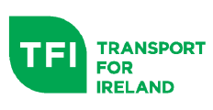

- Events must be held during Bike Week 2022 May 14th to 22nd.
- Bike Week grants are awarded towards the organisation and running of events and not for capital investment projects, such as the construction of bike stands or the purchase of bicycles.
- Details of events should be submitted on or before Thursday the 31st of March, 2022 in advance of Bike Week for upload to the Bike Week website.
- Do not provide funding/part-funding for training similar to CYCLERIGHT training, unless provided by CYCLERIGHT trainers and approved by Cycling Ireland.
- No payment should be made to volunteer persons/volunteer organisations coordinating/running events.
- Final Report to include metrics for all events.

(Further details on Application Form)

