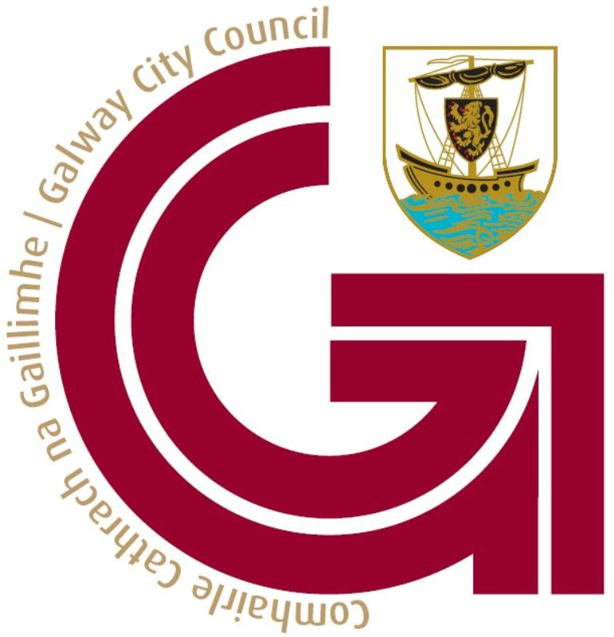 Comhairle Cathrach na Gaillimhe – Galway City Council
Foirm Achomhairc d'Fhógra Muirear Seasta - Fixed Charge Notice Appeal Form

Uimh. Ticéid/Ticket No: ________________ Cláruimh Feithicle/Vehicle Registration : ________________
Ainm Úinéara Cláraithe/Registered Owner Name  ______________________________________________________________  Seoladh an Úinéara Cláraithe/  Address of Registered Owner:  ___________________________________________________________  ___________________________________________________________  Eircode: ________________________________________________  Fón/Phone: ____________________________________________  Ríomhphost/Email:  ___________________________________________________________  Siniú/Signature:_______________________________________  Dáta/Date:______________________________________________ | Tiománai Ainmnithe Ainm /Nominated Driver Name  ___________________________________________________________  Seoladh an Tiománai Ainmnithe/  Address of Nominated Driver:  ____________________________________________________________  ____________________________________________________________  Eircode: _________________________________________________  Fón/Phone: _____________________________________________  Ríomhphost/Email:  ____________________________________________________________

Comhlánaigh an fhoirm iomlán, le do thoil. Glacfar le hachomhairc i scríbhinn nó ar an ríomhphost leis an eolas/leis
an gcáipéisíocht ábhartha.
Please complete form in full. Appeals will be accepted in writing or by email with accompanying relevant
information/documentation.

Tabhairt cuntas iomlán ar shonraí an Achomhairc agus ceangail aon cháipéisíocht a thacaíonn leis, leis seo/
Please fully outline details of Appeal and attach any supporting documentation.

____________________________________________________________________________________________________________________________________________________________________________________________________________________________________________________________________________________________________________________________________________________________________________________________________________________________________________________________________________________________________________________________________________________________________________________________________________________________________________________________________________________________________________________________________________________________________________________________________________________________________________________________________________________________________________________________________________________________________________________________________________________________________________________________________________________________________________________________________________________________________________________________________________________________________________________________________________________________________________

- Ní mheasfar achomharc ach amháin é sin atá faighte ag Comhairle Cathrach na Gaillimhe laistigh de 28 lá de dháta eisiúna an Fhógra Muirear SeastaBíodh a fhios agat go méadóidh na fíneálacha 50%, 28 lá i ndiaidh eisiúna. Mura n-éireoidh le d'achomharc, beidh tú faoi dhliteanas don táille bhreisithe seo.
- Caithfear na cáipéisí tacaíochta ar fad atá mar chuid de do bhuniarratas achomhairc a chur isteach. Ní ghlacfar le/mheasfar cáipéisí breise nuair atá achomharc curtha isteach
- Ní mheasfar achomhairc ach amháin i gcás toscaí maolaitheacha

- Be advised that fines automatically increase by 50%, 28 days after issue. If your appeal is unsuccessful, you will be liable for the incremented charge.
- All supporting documents must be submitted as part of your original appeal application. Additional documents will not be accepted/considered once an appeal has been submitted.
- Appeals will only be considered in extenuating circumstances.

Seol an Achomhairc ar ais chuig / Return Appeal to:
An Rannóg Tráchta, Traffic Section, Comhairle Cathrach na Gaillimhe, Galway City Council,
Halla na Cathrach, City Hall, Bóthar an Choláiste, Gaillimh /College Road, Galway H91 X4K8
Nó ar an ríomhphost/or on email: customerservice@galwaycity.ie
Ní mheasfar achomhairc d’aon cheann de na cionta seo a leanas
- Feithicil a pháirceáil i spás páirceála atá faoi réir íocaíocht táillí, gan an táille sonraithe a íoc, nó teip ar dhiosca páirceála bailí nó ceadúnas eile a thaispeáint, ie Cúramóir, Cónaitheoir nó Cuairteoir
- Stopadh nó páirceáil i nGlanbhealach ag am ar bith
- Feithicil a pháirceáil in áit a bhfuil cosc air eg lána/cuas bus, stad tacsaí, bá lódála nó i limistéar coisithe, nó limistéir chosctha eile
- Feithicil a pháirceáil ar línte buí dúbailte
- Feithicil a pháirceáil go hiomlán nó leathpháirceáil ar chosán
- Páirceáil d'aon chineál eile atá mídhleathach
- Teip ar Dhiosca Mótarchánach reatha a thaispeáint

Appeals will not be considered for any of the following offences
- Parking a vehicle in a parking place in which parking is subject to the payment of fees without paying the specified fee – or failure to clearly display a valid parking disc or other permit, ie. Carers, Residents or Visitors.
- Stopping or parking in a Clearway at any time.
- parking a vehicle in a place prohibited, e.g. bus lane/bay, taxi rank, loading bay, or in a pedestrianised area or any other prohibited areas.
- parking a vehicle on double yellow lines.
- Parking a vehicle wholly or partly on a footpath.
- Any other form of illegal parking.
- Failure to display current Tax Disc

