Merlin Woods Restoration Project
Galway City Council is advancing plans to replant Merlin Woods as a native woodland, creating a more resilient habitat and community amenity following the extensive damage caused by Storm Eowyn in January 2025.
Since March 2026 the Council have engaged and listened to multiple stakeholders when planning the Merlin Woods Restoration Project. Based on the outcome of some of those engagements, three different types of expert advice were sought; ecological, arboricultural, and zoological. The clear advice from all three experts is to progress with the clearance of the area as identified, both from a habitat and human safety perspective.
The Council undertook a public procurement process to secure the most efficient and cost advantageous solution to the clearance works and to plan the restoration of the area as a native woodland.
Following the public procurement process and research undertaken by the Council, the best outcome in this instance is to utilise the timber asset to pay for the clearance works. This in turn is cost neutral to the Council.
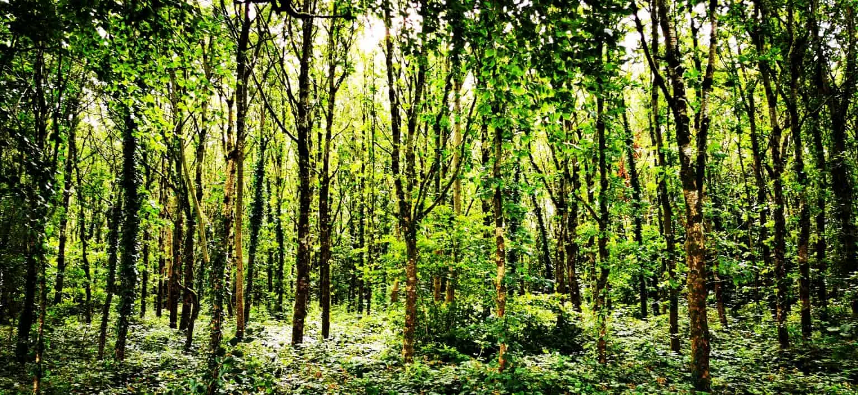
This is what Merlin Woods could look like in 10-15yrs time
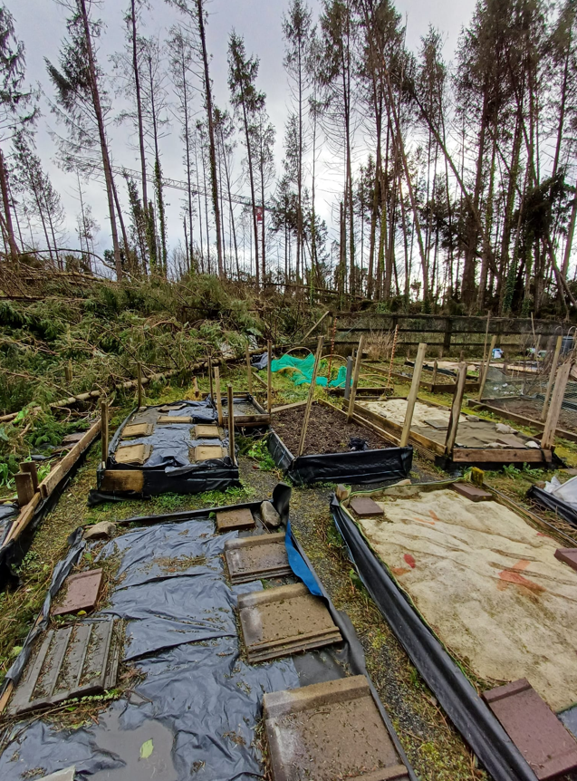
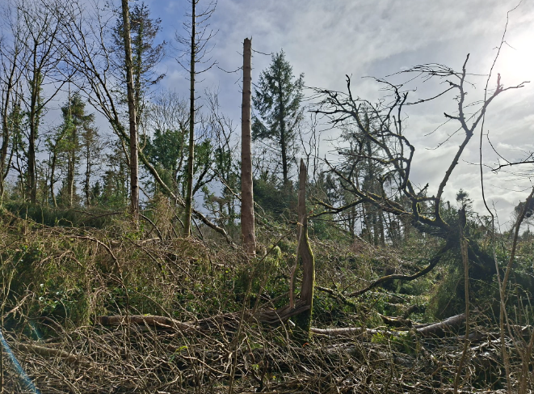
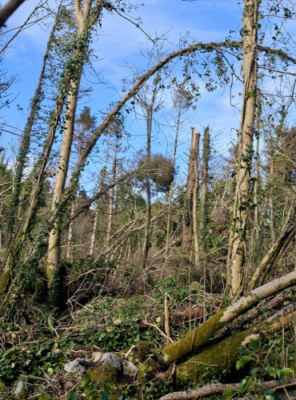

This is Merlin Woods currently

The following is some information about the project in a Q&A format.
Q. Why are Galway City Council carrying out tree clearance in Merlin Woods?
For decades, Merlin Woods has been a mix of broadleaf and conifer trees and has been enjoyed by people and wildlife alike. Approximately 50% of the woodland is made up of Norway spruce, which were planted in the 1960s as a commercial plantation crop. The vast majority of these trees were severely damaged during Storm Eowyn.

It is worth noting that the areas least affected by Storm Eowyn are made up predominantly of native and broadleaf species, demonstrating the resilience of native woodland. Norway spruce is not a native species.

What is the plan?
The plan is in two stages
Stage 1 – Clearance of storm damages trees
- Clear trees that have been damaged by Storm Eowyn
Stage 2 – Replanting with native species & restoration of the woods as public amenity
- NeighbourWood Scheme application to the Department for funding for restoration works
- Immediate planting post clearance to create corridors for wildlife
- Planting the woodland with native species post award of funding

Objectives of the plan
- To bring the woodland back into safe use by the public as an urban woodland
- To replant it as a native woodland under the NeighbourWood Scheme
- To put in amenity features funded by the NeighbourWood Scheme
- The plan includes retention of
  - existing native and broadleaf trees
  - protection of limestone/karst habitats
  - protection of national monuments and built heritage
  - measures to limit the impact on stonewalls
The plan includes measures to minimise
  - The impact on the wildlife
  - The impact habitats
  - Planting immediately post clearance to create corridors for wildlife
  - A feeding programme for native squirrels prior to commencement

Who did we talk to?
Stakeholder consultation - GCC | Operations | Completed
Stakeholder consultation - NPWS | Ecology | Completed
Stakeholder consultation #1 - Locals | Operations | Completed
Stakeholder consultation - Friends Merlin Woods | Ecology | Completed
Stakeholder consultation - GCC | Operations | Ongoing
Stakeholder consultation Round - NPWS | Ecology | Completed
Stakeholder consultation Round #2 - Locals | Operations | Completed
Stakeholder consultation - Arborist | H&S | Completed
Stakeholder consultation, project ecologist, Friends of Merlin, University of Galway | Operations | Completed
Stakeholder consultation Round #2 - Councillors | Operations | Completed
Stakeholder consultation Round #2 - Friends Merlin Woods | Ecology | Completed
Stakeholder consultation - HSE Merlin Park | H&S | Completed
Stakeholder consultation - Merlin Lane Residents | H&S | Completed

Q. What will be felled and what will be retained?
The total area of Merlin Woods is 33.41 hectares

18 hectares will be retained (that is 54% of existing trees)
4.34 hectares of the retained area is standing conifer Norway spruce.

15.41 hectares will be cleared. This area is comprised of fallen or damaged conifer trees which need to be cleared. There is full agreement from all stakeholders on the need to remove 80% of this area.

There is an area (circa 20%) that is mainly standing conifer trees, with some fallen trees. The stability of this area is compromised by the storm damaged trees to the south and north. Retaining the standing trees would present a high risk to the public using the nearby footpaths. The footpaths must remain open to the public who use them to get through the woodland.

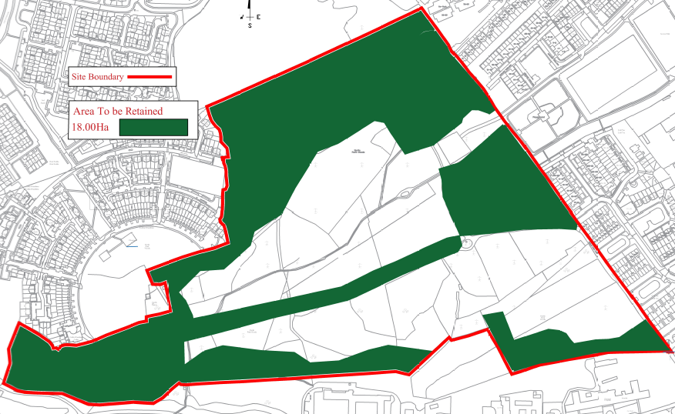

What is being done to protect the red squirrels?
Expert advice regarding the impact on the red squirrel population was sought from University of Galway, Zoology Department.
This advice informed the
- areas of trees to be protected during clearance
- feeding measures GCC can put in place immediately
- post clearance planting to support squirrel movement in the forest
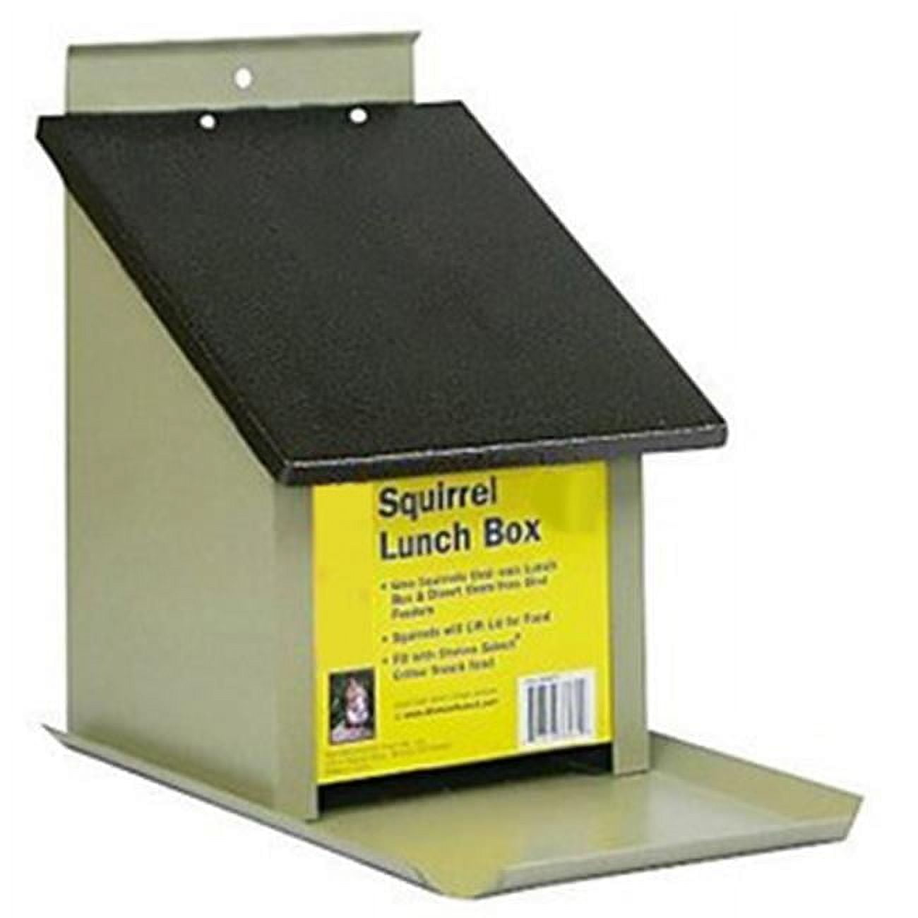
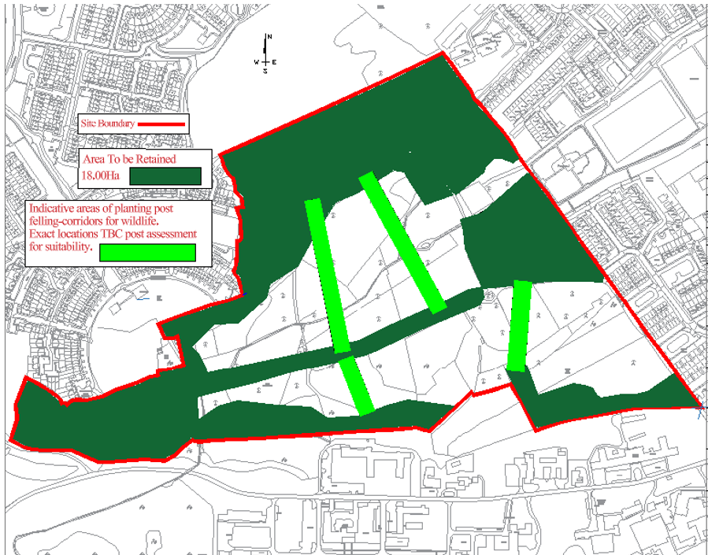

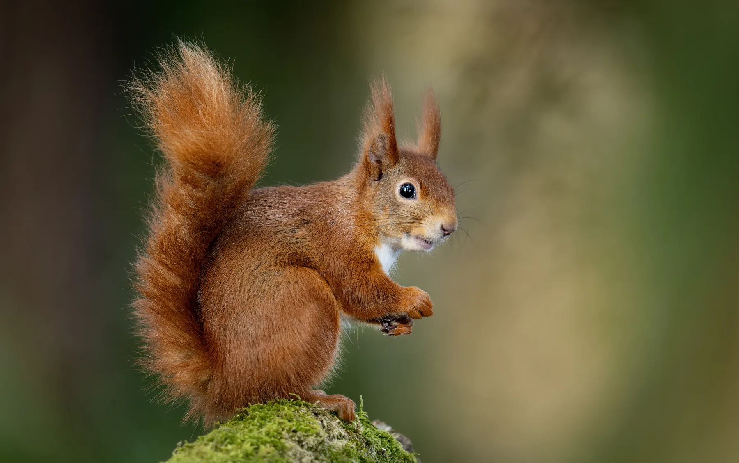

Q. How are the stages of work being funded?
Stage 1 of the project is the clearance of storm damages trees which is being carried out on a cost-neutral basis to the Council. This means that there will be no payment to the contractor for the work in harvesting the trees.
Stage 2 of the project is the replanting of the conifer areas with native species & restoration of the woods as public amenity. Funding will be sought for this through funding from the Department of Agriculture, Food and the Marine through the NeighbourWood Scheme. This could include up to 85% of the costs. The reminder will need to be covered by other funding streams, and/or from the Council’s budgets.

For more information on the NeighbourWood Scheme fund please go to .link

