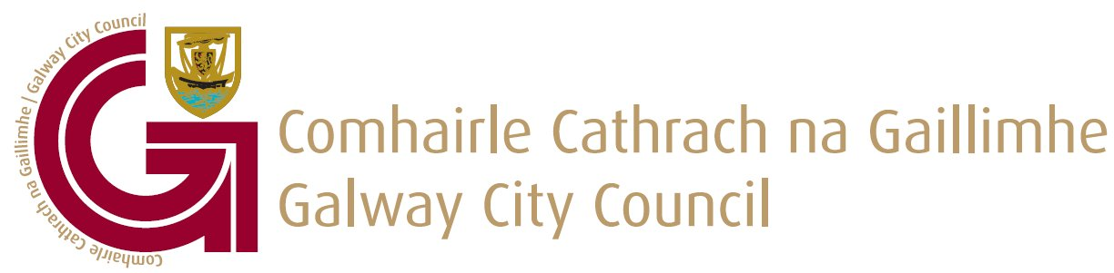
Pre-Planning Consultations
Section 247 Planning and Development Act 2000 (as amended)

Form to be completed for all pre-planning consultations with Galway City Council and should be e-mailed to: preplanning@galwaycity.ie

Depending on the nature of the enquiry or scale and complexity of the development, pre-planning consultation may be delivered via:
- MS Teams
- In Person Meetings
- Telephone Correspondence
- E-mail Correspondence
The agent will be advised by e-mail of the time, date and nature of the meeting.

Pre-planning advice is given in good faith and without prejudice to the formal consideration of any subsequent planning application. Section 247(3) of the Planning and Development Act 2000, as amended states that “the carrying out of consultations shall not prejudice the performance by a Planning Authority of any other of its functions under this Act, or any regulations made under this Act and cannot be relied upon in the formal planning process or in legal proceeding.”

BEFORE FILLING OUT THIS FORM PLEASE NOTE THE FOLLOWING:
Failure to complete this form or attach the necessary documentation, or the submission of incorrect information or omission of required information will lead to the invalidation of your application. Therefore, please ensure that each section of this form is fully completed and signed, entering n/a (not applicable) where appropriate, and that all necessary documentation is attached to the application form.

DATA PROTECTION
It is the responsibility of persons or entities wishing to use any personal data on a planning application form for direct marketing purposes to be satisfied that they may do so legitimately under the requirements of the Data Protection Acts 1988 to 2018. The Office of the Data Protection Commissioner states that the sending of marketing material to individuals without consent may result in action by the Data Protection Commissioner against the sender including prosecution.

GDPR COMPLIANCE
In the event that a planning application is made following this pre-planning application, the contents of this pre-planning application will be placed on the planning file for public inspection and displayed on our website www.galwaycity.ie

- Applicant:
Name of Applicant:
Address of Applicant:
Eircode:
Telephone: | Mobile:
Telephone: | Landline:
E-mail:

- Applicant’s Interest in the Site:
I confirm that I am the legal owner of this site: Yes No
If no, is written consent from the land owner included Yes No

- Agent Details:
Has an Agent been engaged at this stage? Yes No
If you have answered yes to the above, please provide the following information:
Name of Agent:
Address of Agent:
Eircode:
Telephone: | Mobile:
Telephone: | Landline:
E-mail:

To whom should all correspondence be sent? Applicant Agent

- Site of Proposed Development:

Postal Address/Townland/Location of the Proposed Development (sufficient to identify the site in question)
Eircode
Site Location Map  (Scale 1:1000) | *It is essential that you attach an appropriate map which clearly outlines the location and extent of the proposal site. Failure to do so will result in your pre-planning consultation application being returned to you.

- Details of Proposed Development:
Please provide a clear and detailed description of the nature and purpose of the proposed development:

Is the development a large-scale Residential development (100 or more units, 200 student bed spaces? Yes No

Is the development for 10 or more residential units or for commercial development greater than 1000sq.m Yes No

Previous Pre-Planning Application Number(s) or date(s) (if applicable)
Previous Planning Application Number(s) (if applicable)

- Additional Documentation:
Please provide a brief description of the proposed development, which should include information, drawings or representations on the following:
Information | Enclosed
- Site location map sufficient to identify the land,  at appropriate scale | Yes No
- Drawings of proposed development | Yes No
- Any supporting information as necessary including preliminary drawings, photographs, design layout or sketches | Yes No
- Surveys | Yes No

Please e-mail completed Pre-Planning form and all associated documentation to:
preplanning@galwaycity.ie

You will be contacted by the Planning Team once your submission has been reviewed.

