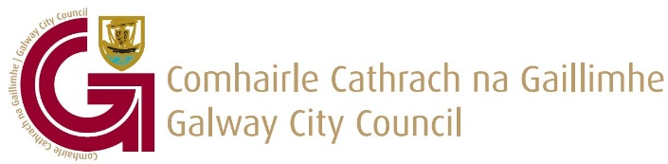

Galway City Community Litter Clean-Ups
Registration Form
Conditions for Clean-Up Support
Please read carefully through the conditions for community clean ups before completing the application form:
- Resident association/group/organisation must register the week prior to the clean with Galway City Council.
- The Community Clean-Up is only for the public open spaces in your area.
- All bags used should be the official Galway City Council clean-up bags only. All bags must contain only litter from the clean-up. There is no longer a green waste collection service. Bags containing green waste will NOT be collected. Bags containing household waste will NOT be collected. Any clean-up bag containing both litter and green waste will NOT be collected.
- Official clean-up bags, gloves and litter pickers can be collected from City Hall, College Road. There is a limited amount of Clean-Up items given out to each Resident association/group/organisation. Please note, that this rule has been put in place so that each Resident association/group/organisation gets a chance in receiving Clean-Up items for their organised clean-up.
- Resident association/group/organisation are encouraged by Galway City Council to hold on to any litter pickers/gloves and unused bags that they receive as part of the Community Clean-Up Initiative for a future clean-up.
- If a large quantity of clean-up items are given out continuously during the year to a Resident association/group/organisation and/if a collection of clean-up bags has not been taken up, Galway City Council may refuse to give out further Community clean-up items.
- Community Clean-Up bags will be collected on Wednesday only, no exception. The deadline for registering for collection of clean-up bags is Tuesday at 12 noon. Any requests after this time will be allocated to the following Wednesday collection date.
- Official clean-up bags will only be collected from outside designated house in the area where the clean-up is taking place. The bags must be placed beside the public pathway.

Rules regarding Beach Clean-ups/ Woodland areas:
- Resident Association/Group/ Organisations are encouraged to check with customerservices@galwaycity.ie , prior to the collection of the clean-up bags regarding the location of the pick-up point.
- Under no circumstances can clean-up bags be placed beside public bins.
- Please make sure that the bags will contain litter waste only, as any green waste in the clean-up bags cannot be collected.
Items Included in the Community Clean-Up Bundle:
2 Roll of bags (25 bags per roll) 5 pairs of gloves 4 Litter Pickers

I can confirm that I have read and understand the conditions for ordering of clean-up equipment and the collection of Galway City Community clean-up bags ( Tick box )

If you would like to organise a clean-up in your area, please fill out the details below.

Name of Resident Association/ Group/Organisation
Name

Address (including Eircode)

Telephone Number
E-mail Address
Date of proposed Clean-Up
Date bags will be Ready for Collection
(Wednesday Only)
Approximate Amount of Bags to be Collected
Location for Collection of Bags (Including Eircode)
https://finder.eircode.ie/#/

Your data will be stored and processed in line with Galway City Council’s Data Protection Guidelines under GDPR.

