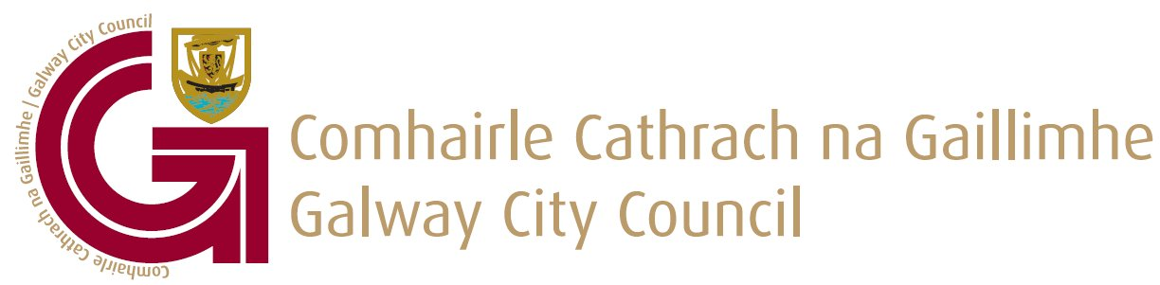

To the Chairperson & each member of the Economic, Community and Cultural Development SPC

Date: May 18th 2022

Dear Member,

I wish to advise that the next meeting of the Economic, Community and Cultural Development SPC will take place on Thursday 26th of May 2022 at 2.00- 4.00pm in the Council chamber and via MS Teams. The agenda is as set out below and I request your attendance at this meeting. Could you please advise me in advance by return email if you intend to attend virtually or in person.

Yours sincerely

____________________

Brian Barrett,
Head of Economic Development & Culture Unit

AGENDA

- Confirmation of minutes of the, Economic, Community & Cultural Development SPC meeting held on Thursday 17th February 2022

- Matters Arising

- Update from the Community Department

- Western Regional Enterprise Plan Presentation

- Local Economic and Community Plan Update

- Update on Tourism Projects

- Macnas presentation

- A.O.B

