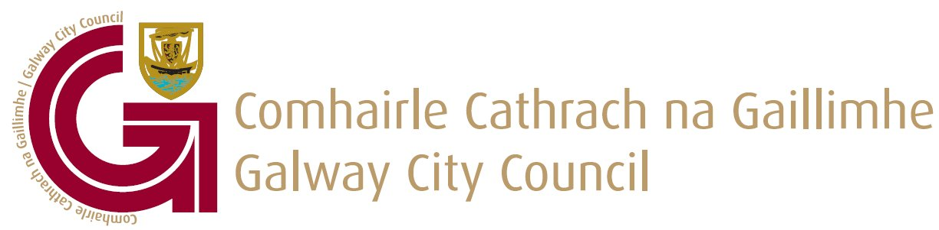

To the Chairperson & each member of the Economic, Community and Cultural Development SPC

Date:

Dear Member,

I wish to advise that the next meeting of the Economic, Community and Cultural Development SPC will take place on Friday 19 February at 2.00pm via MS Teams.
The agenda is as set out below and I request your attendance at this meeting:

Yours sincerely

____________________
Brian Barrett
Director of Services, Economic Development,
Community & Culture, Water Services & Support Services,
(Incorporating ICT & Corporate Services) Directorate

AGENDA

- Confirmation of minutes of the, Economic, Community & Cultural Development SPC meeting held on 11th December 2020

- Matters Arising

- SPC work programme for 2021

- Everybody matters – Cultural Strategy Update

- Covid 19 Community Response Forum Update – Keeping Well

- Presentation by Western Regional Drug Taskforce – Planet youth for Galway City

- Update on Atlantic Economic Corridor initiatives

- Update on Restart Grants and Business supports

- AOB

