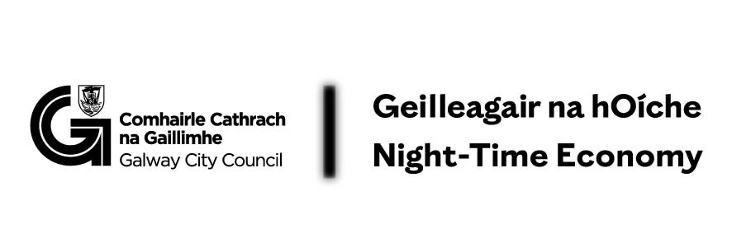Nice Toilet Galway City Pilot Scheme: Expression of Interest
Thank you for your interest in the Nice Toilet Galway City Pilot Scheme.
Eligible locations:
Galway City Centre, including the following neighbourhoods:
Eyre Square
Woodquay
The Latin Quarter
The Westend
Salthill Village
Please refer to map, if you are unsure whether your business is eligible, please contact Kate Howard at kate.howard@galwaycity.ie.

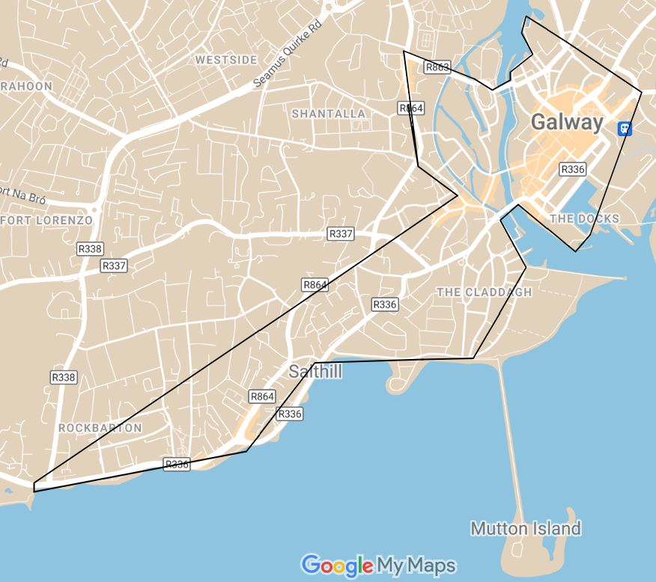

Please provide the following information:

Business Name:
Address:
Contact Name:
Email Address:
Phone Number:
Business Type: (e.g., Restaurant, Café, Pub, Shop)
Restroom Details:
• Number of stalls:
• Accessibility: (Yes/No)
• Changing facilities: (Yes/No)
• Opening Hours:
Additional Information: Please share any additional information you think is relevant to your participation in the pilot scheme.

By submitting this form, you express your interest in participating in the pilot scheme and agree to be contacted by Galway City Council to discuss further details.
Please email forms to c&c@galwaycity.ie
Privacy Notice: The information provided in this form will be used solely to evaluate your suitability for participation in this pilot scheme and will not be shared with any third parties without your consent.

Nice Toilet Galway City Pilot Scheme – Terms and Conditions

- Pilot Scheme: Galway City Council is launching a 12-month pilot scheme named Nice Toilet Galway City Pilot Scheme in partnership with businesses in the city centre and Salthill Village.
- Participation: Businesses participate voluntarily and may opt-out at any time by providing written notice to Galway City Council.
- Financial Contribution: Participating businesses will receive an annual contribution of €500 (paid in two instalments) in exchange for allowing the public to use their restroom facilities, without making a purchase.
- Signage: Businesses will display a Nice Toilet Galway City sticker in their window to inform the public of their participation in the scheme.
- Right to Refuse Entry: Participating businesses retain their legal right to refuse entry to their premises, as per the Safety, Health & Welfare at Work Act 2005.
- Feedback and Evaluation: At the end of the 12-month pilot, businesses will provide feedback to Galway City Council on their experience with the scheme.
- Liability: By participating in the scheme, businesses agree to accept users of their restroom facilities as their own customers and assume any associated liabilities. Participants must maintain Public Liability insurance with a minimum indemnity limit of €2.6 million.
- Termination: Galway City Council reserves the right to terminate the pilot scheme early, with written notice to participating businesses, in the event of unforeseen circumstances or budget constraints.
- Amendments: Galway City Council may amend these terms and conditions at any time, with written notice to participating businesses.
- Acceptance: By signing this agreement, businesses indicate their acceptance of these terms and conditions and their commitment to participating in the Nice Toilet Galway City Pilot Scheme.

