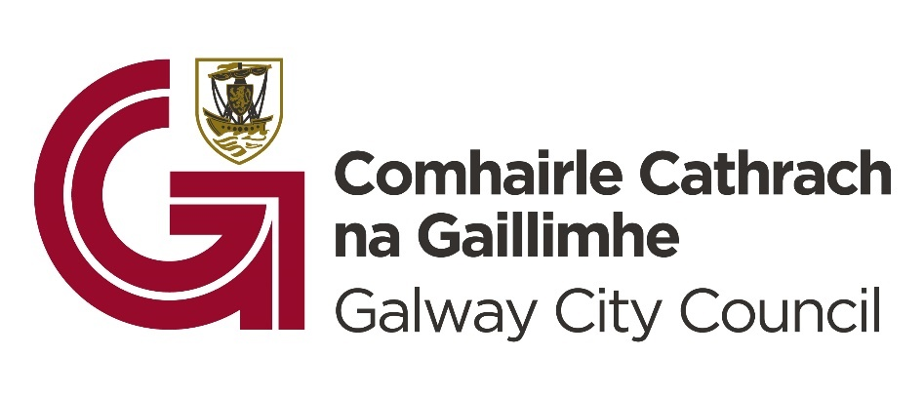

Galway City Council Café Lates Pilot Initiative
About and Guidelines
Galway City Council is pleased to announce "Café Lates," a pilot grant initiative designed to foster a vibrant and diverse late-night café culture. We invite local cafés located in Galway city centre and Salthill to apply for funding to introduce engaging cultural programming after 6pm, during August to November 2024.
As one of nine pilot cities nationwide actively shaping Irelands night-time economy, Galway is committed to enhancing the city's after-6 p.m. offerings. "Café Lates," a direct response to our public consultation aims to:
- Diversify Nightlife: Expand evening options beyond traditional venues, offering an enhanced experience for residents, workers, and visitors alike.
- Stimulate the Economy: Drive foot traffic and revenue for cafés during evening hours.
The types of programming we envisage and encourage are live performances from local bands to intimate acoustic and DJ sets. Spoken word and poetry, comedy, book clubs, workshops and tastings to themed nights. We also encourage programming that appeals to a youth audience, creating a welcoming and inclusive space for all.
Grant Funding Available
The "Café Lates" grant can cover costs related to:
- Artist Fees
- Marketing & Promotion
- Equipment Rental
- Other Cultural Programming Expenses

Grant Details:
- The pilot scheme will provide up to 90% of funding for the event(s) The minimum grant award is €500 and the maximum grant award is €2,500
- Events must take place from 6pm in Galway City in September and November 2024.
- Events must be completed by November 10th
- Proposals for a series of events over a period of time are encouraged to fully assess demand and feasibility – for example, hosting an event every Thursday for four weeks.
- We welcome applications from cafés across Galway City centre and Salthill.
- We will work with successful applicants to design a schedule that ensures a diverse geographical spread and avoids scheduling conflicts with other Café Late events.
Who Can Apply:
Cafés located in Galway city centre and Salthill that can host events and are interested in piloting cultural events starting from 6 pm during September to November 10th, 2024 are encouraged to apply.
Why Participate?
- Financial Support: Receive funding to offset the costs of hosting cultural events and experimenting with new late-night offerings.
- Increased Visibility: Benefit from promotional support, reaching new audiences and potentially attracting new customers to your café.
- Data-Driven Insights: Gain valuable feedback through participant surveys to understand your audience, refine your offerings, and determine the feasibility of extending your café's hours and programming in the future.
How to Apply:
- Download the application form from the Galway City Council website.
- Complete the form with detailed information about your proposed events/initiatives.
- Apply by [Deadline Date].
- Applications will be reviewed by an independent panel and awarded on a competitive basis.
- Incomplete or late applications will not be considered. Full terms and conditions apply.
- Successful applicants will be notified in August.
Funding Conditions
- Grant payments will be made based on paid invoices and receipts.
- Programmes must be advertised locally, acknowledging Galway City Council and Department of Tourism, Culture, Arts, Gaeltacht, Sport and Media support.
- Grant payments will be made on the basis of paid invoices and receipts submitted along with proof of payment and only for the proposed expenditure submitted on the original application form and subsequently approved in the letter of offer. Cash payments to suppliers are not permitted.
- All successful Grantees are also required to carry out a participant/ visitor survey. This data will help Galway City Council evaluate the success of the pilot and will also help the Council County to gain valuable insights into who is attending the late night events, in what numbers and the visitors overall experience of the events/initiative.
- All successful Grantees will be required to fill out an evaluation questionnaire in relation to this scheme when drawing down funds. This will allow the Galway City Council to evaluate the effectiveness of the funding and also to gain learnings from the pilot.
- Programmes must be advertised locally through various channels to ensure maximum visibility. Kilkenny County Council and the Department of Tourism, Culture, Arts, Gaeltacht, Sport and Media’s support must be acknowledged in public advertising. Logos will be provided to successful applicants.
- Where a grant is allocated for a specific event Galway City Council will not be responsible for the insurance of that event. The organisers must ensure that adequate insurance is in place prior to the commencement of any event / project.
- It is the responsibility of the applicant to ensure that all permissions, approvals, licences or consents needed for your event are secured.
- If your application is successful, evidence of appropriate public liability must be provided. Organisers will also be asked to indemnify Galway City Council on their public liability insurance.
- If applicants intend to work with children and young people, evidence will be requested if successful of having an up to date child protection policy or the child protection policy of your partner organisation.
- If the event is altered, postponed or cancelled – in whole or in part – the Galway City Council Night-Time Economy Advisor must be contacted to discuss the matter.
- Galway City Council and the Department of Tourism, Culture, Arts, Gaeltacht, Sport, and Media must be acknowledged on all publicity, press and marketing material, websites, and social media outlets produced in connection with the undertaking or event. Logos will be sent to all successful applicants
- Copies of all such material produced must be sent to the Night-Time Economy Advisor in advance of the event and included as part of the Evaluation Report.

Eligible Funding:
- Artist Fees: Costs associated with paying artists, performers, etc for their services.
- Security Costs: Expenses related to ensuring the safety and security of the event.
- Event Insurance: Costs for obtaining insurance coverage specific to the event.
- Set-up/Staging Costs: Expenses for setting up the venue, including stages, lighting, and other necessary elements.
- AV Costs and Equipment Hire: Costs for renting audio-visual equipment and any associated fees.
- Photography, Marketing, and Advertising Costs: Expenses related to promoting the event through photography, marketing materials, and advertising campaigns.
- Visitor Survey/Exhibition Survey Costs: Expenses for conducting surveys to gather feedback from attendees.
- Subsidised Entrance Fee/Ticket Fee: Costs for subsidising the entrance fee or ticket price for the event, if applicable.
Ineligible Funding:
- Costs Incurred Before Grant Award: Expenses incurred before the grant is officially awarded will not be covered.
- Equipment Purchase: Costs for purchasing new equipment, including musical instruments, are not eligible.
- Local Authority Rates: Local authority rates or taxes are not eligible expenses.
- Staff Costs: Expenses related to staff salaries or additional staffing costs for extended hours are not covered.
- Accommodation: Accommodation costs for artists, performers, or staff are not eligible.
- Legal and Accountancy Fees: Professional fees for legal and accounting services are not covered.
- Annual Insurance Costs: General annual insurance costs are not eligible, except per-event insurance.
- Food and Beverages: Costs associated with food and beverage service are not eligible.

How will the decision on funding be made?
Grant applications will be assessed using the following criteria:

Project Merit
How the proposal addresses the intended objectives of the funding scheme. Applicants should demonstrate how their proposed event will support the growth of the night-time economy.
30%

Overall Impact
The applicant should indicate the potential economic benefits of their proposed project, for example – the impact on business turnover, and the number of new customers/visitors created.
30%

Viability
The applicant should indicate their experience and capacity to undertake the project and the extent to which the proposed budgets and project plans are cost effective and realistic for the delivery of the intended outcomes.
15%

Sustainability & Accessibility focus
The applicant should indicate how support for their event will contribute to Galway City's vision for a diverse, sustainable, and accessible nightlife? (Consider the environmental impact, inclusivity, accessibility for people with disabilities, age-friendly including youth etc.)
15%

Completed applications must be submitted by email to C&C at Galway City Council E: candc@galwaycity.ie

Appeals:
An appeal may be made by an applicant to xxx if they are not satisfied with the outcome of their application. An appeal must be made within 5 working days of the date of the decision letter/email. The appeal will be reviewed independently and on completion of the review, a decision will issue to the applicant.

Payment Conditions:
Successful applicants will receive a Letter of Offer along with an acceptance slip. This will form the contract between Galway City Council and the organiser/lead applicant and will detail all conditions and requirements which will include all health and safety requirements by you if appropriate, guidance on GDPR imagery that identifies a person in your images and correct consent forms returned. Full details of all conditions will be emailed to successful applicants.
In order to receive payment, the successful applicant must provide the following:
  - A completed Galway City Council “supplier set up form” with tax registration certification and copy of your bank statement header.
  - Evidence that the event has taken place (e.g. photographic evidence, MAX 5, high quality jpeg images must be supplied, copies of press features and evidence that on ALL publicity material about your project acknowledge Galway City Council and Department of Tourism, Culture, Arts, Gaeltacht, Sport and Media with the logos clearly visible, appear and are acknowledged on all print materials, interviews, films produced and social media postings – (Logos will be supplied to you if successful).
  - Receipts for ALL PAYMENTS applicable to the funding approved in the letter of offer. Cash payments to suppliers are not permitted.
  - Payment will be made by Electronic Fund Transfer (EFT) only.
  - Failure to return the required report and related receipts will forfeit the grant.

