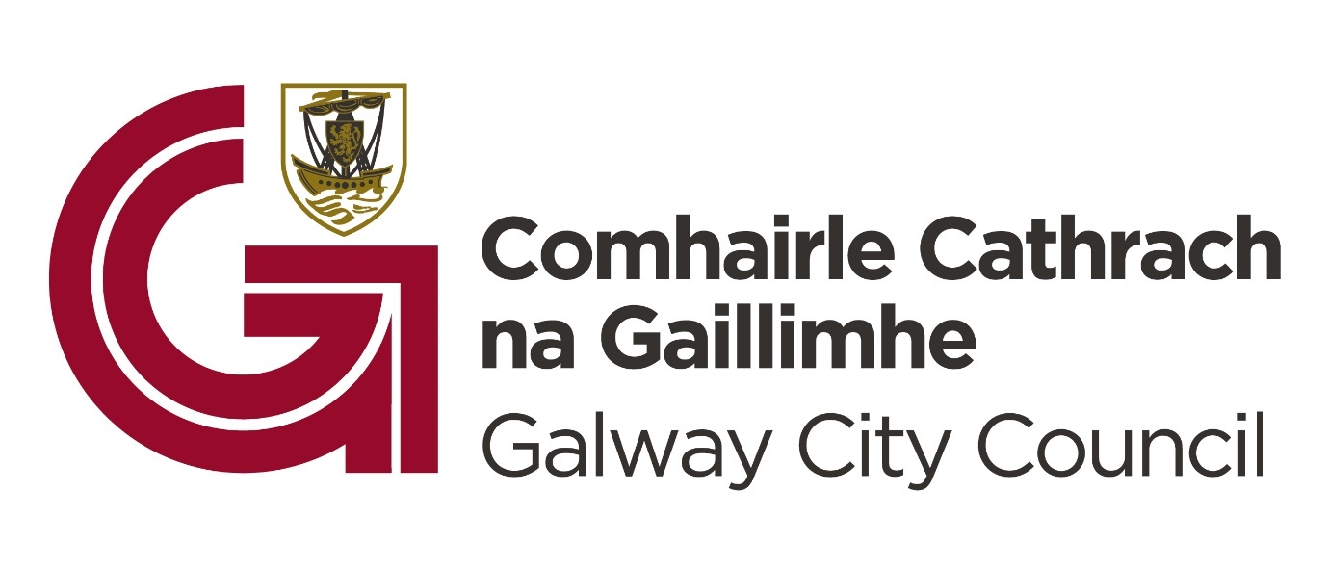
Galway City Council Café Lates Application Form
1. Applicant Details:
Name of Applicant:
Business:
Name and Title of Contact Person (for payment purposes):
Tel:
Email:
Website:
Social media:
Address:
Standard business closing hours:
2. Event/Initiative Details:
Title of event: (this will be used for advertising):
Summary of your project proposal, including proposed creatives involved (max 300 words):
Note: should your application be successful, this summary will be used in reports regarding who & what we have funded in 2024. If you require support identifying potential acts, please contact Galway City Arts Office arts@galwaycity.ie

Type of Activity (e.g., Live Music, comedy etc.)
Target Audience: (Families, Young Adults, Older Audience, General public, etc.)
What are the confirmed/proposed date(s) for your event?
Proposed time of your event? Please note we encourage events that go into the later evening.
Venue (full address, including Eircode):
End date (if more than one event): (Note: All projects must be completed by November 10th)

3. Project Merit (30%):
How does the proposal address the intended objectives of the funding scheme (fostering a late-night café culture to support the growth and diversification of the night-time economy in Galway City)? Max word count 200.

4. Overall Impact (30%):
Estimated Economic Impact for Galway City: (based on realistic estimates/previous measurement)

Estimated audience figures and how this is concluded: (based on realistic estimates/previous measurement/venue capacity)

How will you monitor and evaluate your project? (e.g., sales, feedback forms, footfall, social media engagement, etc.) Please note a survey will be provided.

5. Viability (25%):
Please provide details of your experience in delivering events of this nature:

Will a booking link be provided to monitor attendance?

How will you advertise & promote your project? Please include links to your business website/social media.

Please outline the longer-term potential for this event/activity. If your event(s) is deemed a success, will you consider hosting future events and extending opening hours?

6. Sustainability & Accessibility Focus (15%):
How will your project contribute to Galway City's vision for a diverse, sustainable, and accessible nightlife? (Consider the environmental impact, inclusivity, accessibility for people with disabilities, age-friendly including youth, and so on.)

How will you ensure your event is sustainable? (Waste reduction, energy conservation, etc.)

What steps will you take to ensure your event is accessible to people with disabilities?

7. Funding:
What is the estimated overall cost of the event/project? €
How much are you requesting from Galway City Council? €
How much match funding are you providing? (must be a minimum of 10%) €
Are you applying for funding from any other sources? Yes/No
If yes, please provide details:
If no, please indicate how you intend to fund the balance of your costs:
8. Income (if applicable):
Please provide a detailed breakdown of all income sources:
Item Estimated Income (€):
9. Project Costs/Expenditure:
Please provide a detailed breakdown of costs to be funded under this scheme:
Element of Work/Programme/Item | Cost (€):
10. Acknowledgement:
How will you publicly acknowledge the contributions of Galway City Council and the Department of Tourism, Culture, Arts, Gaeltacht, Sport, and Media?

11. Disclaimer
Please review the disclaimer and data protection statements and sign if you agree.
Galway City Council will not be liable in respect of any loss, damage or costs of any nature arising directly or indirectly from this application or the subject matter of the application. Galway City Council, its servants, or agents shall not at any time in any circumstances be held responsible or liable in relation to any matter whatsoever arising in connection with the development, planning, construction, operation, management and/or administration of individual projects. A copy of PL Insurance noting Galway City Council indemnity is attached herein.

I/we have read the above terms and conditions and I certify that the information supplied here is a true and fair representation of this businesses position.
Signed:
Date:

12. Data Protection

Galway City Council collects some personal data during the application and processing of this grant scheme, particularly, names, addresses and contact details (emails and telephone numbers). These details are necessary for the consideration and adjudication on the grants scheme. The grant applications are sometimes shared between relevant City Council Departments for the purpose of supporting the application and also to ensure that similar events are not double funded, to process payments and in relation to other festival/events funded by the Council. At all stages the personal data is handled in full accordance with the Data Protection Legislation.

Your express consent is required, acknowledging that you understand that you may be submitting personal data. Please sign here by way of agreement.

Signed: ________________________________ Date: _____________________________

