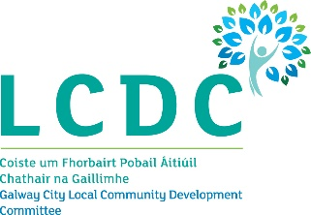
17th April 2024

To: Each Member of the Galway City Local Community Development Committee (LCDC)

A Chara,

I wish to advise that the next meeting of the Galway City Local Community Development Committee will take place on Wednesday 24th April 2024 at 5.00pm online.

The Agenda for the meeting is set out below and I request your attendance.

AGENDA
- Welcome and Introductions

- Confirmation of the minutes of the Galway City LCDC meeting held on 28th February 2024 (attached)

- Local Area Child Poverty Action Plan Pilots – Presentation by Morgan Mee, CYPSC Co-ordinator (attached)

- Social Inclusion and Community Activation Programme (SICAP)
  - SICAP Annual Plan 2024 (report to follow)
  - 2022 SICAP Internal Audit (attached)

- AMACH LGBT+ - Update on CDP Programme - Presentation by Fiona McDonagh, Amach LGBT (attached)

- Community Recognition Fund 2024 (attached)

- Any Other Business

Is mise, le meas,


________________
Dermot Mahon
Chief Officer
Galway City LCDC

