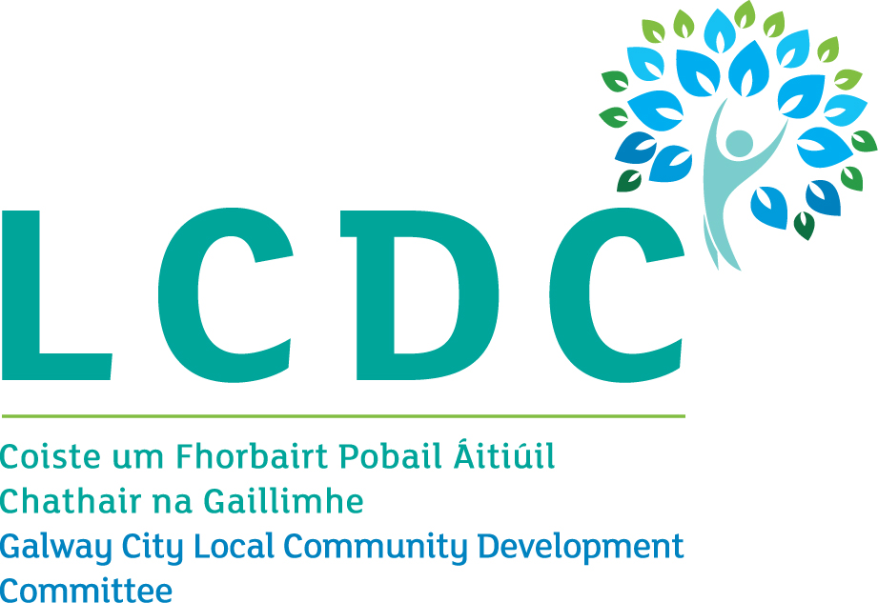
LCDC Name | Galway City
Chairperson | Elaine Harvey  Trade Union
Chief Officer | Caitriona Morgan
Statutory Interests
Sector | Name | Organisation
Local Authority Elected Members | Councillor Martina O’Connor | Galway City Council
Local Authority Elected Members | Councillor Owen Hanley | Galway City Council
Local Authority Officials | Brendan McGrath | C.E Galway City Council (Temp until rep nominated)
Local Authority Officials | Breda Fox | Local Enterprise Office
State Agencies | Anne O’Neill | Health Service Executive
State Agencies | Sinead Morgan | Galway Roscommon Education & Training Board
State Agencies | Regina Higgins | Department of Employment Affairs and Social Protection
Non Statutory Interests
Sector | Name | Organisation
 | James Coyne | Galway City Community Network (GCCN)
 | Lorraine Grimes | Galway City Community Network (GCCN)
 | Anne Marie Stokes | Galway City Community Network (GCCN)
 | Maria Molloy | Galway City Community Network (GCCN)
 | Niall Ó Brolcháin | Galway City Community Network (GCCN)
Trade Union | Elaine Harvey  (Chairperson) | Trade Union
Employers/Business | Frank Greene | Galway Chamber
Local Development | Declan Brassil | Galway City Partnership

