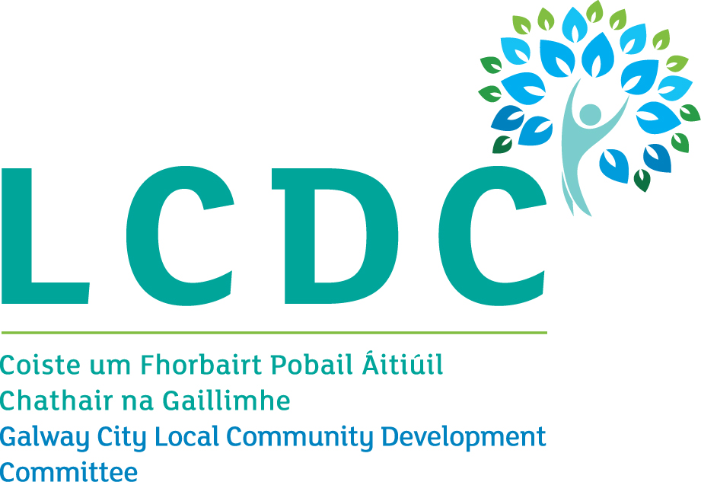
LCDC Name | Galway City
Chairperson | Elaine Harvey  Trade Union
Chief Officer | Dermot Mahon
Statutory Interests
Sector | Name | Organisation
Local Authority Elected Members | Councillor Martina O’Connor  Councillor Alan Curran | Galway City Council  Galway City Council
Local Authority Officials | Patricia Philbin | C.E Galway City Council
Local Authority Officials | Valerie Kelly | Local Enterprise Office
State Agencies | Anne O’Neill | Health Service Executive
State Agencies | Sinead Morgan | Galway Roscommon Education & Training Board
State Agencies | Regina Higgins | Department of Employment Affairs and Social Protection
Non Statutory Interests
Sector | Name | Organisation
 | James Coyne | Galway City Community Network (GCCN)
 | Joanne Laffey | Galway City Community Network (GCCN)
 | Anne Marie Stokes | Galway City Community Network (GCCN)
 | Fiona McDonagh-Delaney | Galway City Community Network (GCCN)
 | Lorraine Lally | Galway City Community Network (GCCN)
Trade Union | Elaine Harvey  (Chairperson) | Trade Union
Employers/Business
Local Development | Linda Sice Brogan | Galway City Partnership

