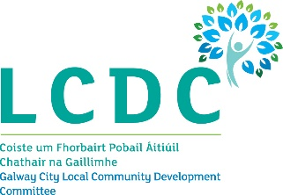

1st November 2023

To: Each Member of the Galway City Local Community Development Committee (LCDC)

A Chara,

I wish to advise that the next meeting of the Galway City Local Community Development Committee will take place on Wednesday 8th November 2023 at 3.00pm in the Council Chamber, Galway City Council, College Road, Galway and online.

The Agenda for the meeting is set out below and I request your attendance.

AGENDA
- Welcome and Introductions

- Confirmation of the minutes of the Galway City LCDC meeting held on 13th September 2023
(Attached)

- SICAP 2023 Case Study Video - Community Response to Domestic Abuse Western Regional Network: Interagency & Community Collaboration.

Narrative document to accompany video attached https://youtu.be/al4g82D_vio?feature=shared

- Community Recognition Fund 2023 – (Report attached)

- Healthy Galway City – To receive an update on Healthy Ireland Fund (HIF) Round 4 2023 – 2025 and 2023 activities (Report attached)

- Any Other Business

Is mise, le meas,

__________________
Dermot Mahon
Chief Officer
Galway City LCDC

