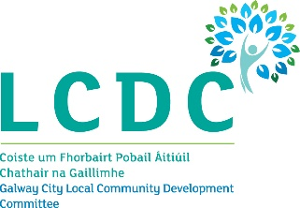

6th September 2023

To: Each Member of the Galway City Local Community Development Committee (LCDC)

A Chara,

I wish to advise that the next meeting of the Galway City Local Community Development Committee will take place on Wednesday 13th September 2023 at 5.00pm online only via MS Teams.

The Agenda for the meeting is set out below and I request your attendance.

AGENDA
- Welcome and Introductions

- Confirmation of the minutes of the Galway City LCDC meeting held on 19th July 2023
(Attached)

- Galway City Local Economic & Community Plan (LECP)
Draft Framework Plan 2024 – 2029
Draft Implementation Plan 2024 - 2025

- Social Inclusion and Community Activation Programme (SICAP 2024+) – To hear an update

- Any Other Business

Is mise, le meas,

__________________
Dermot Mahon
Chief Officer
Galway City LCDC

