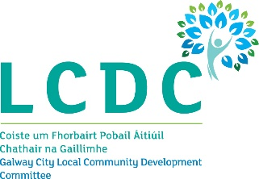
21st February 2024

To: Each Member of the Galway City Local Community Development Committee (LCDC)

A Chara,

I wish to advise that the next meeting of the Galway City Local Community Development Committee will take place on Wednesday 28th February 2024 at 3.00pm in the Council Chamber, Galway City Council, College Road, Galway and online.

The Agenda for the meeting is set out below and I request your attendance.

AGENDA
- Welcome and Introductions

- Confirmation of the minutes of the Galway City LCDC meeting held on 13th December 2023
(Attached)

- Draft Local Community Development Committee Annual Report 2023 – Report attached

- Social Inclusion and Community Activation Programme (SICAP)
  - SICAP Annual Plan 2024
  - Annual Performance Review of SICAP 2023 - Documents attached

- Local Enhancement Programme 2024 – Grants Approval of LCDC Subcommittee recommendations - Report to issue

- Local Authority Integration Team – Presentation attached

- Any Other Business

Is mise, le meas,

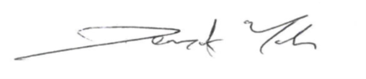
________________
Dermot Mahon
Chief Officer
Galway City LCDC

