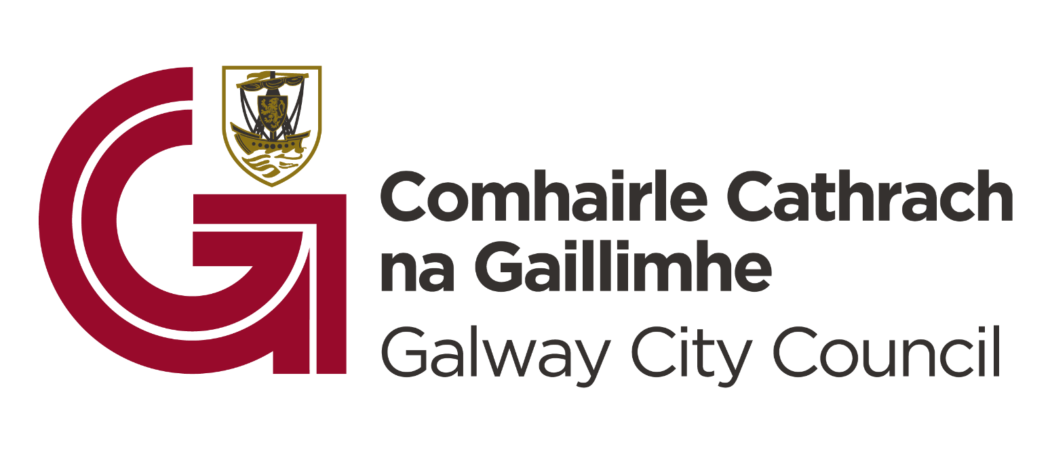
2023 Sports Club Grant Scheme Criteria

Please read the briefing for this year’s grant scheme to ensure you understand the requirements for a successful application. Applications must abide by the criteria as set out below.

Eligible clubs must:

- Be based in the administrative areas of Galway City Council or where a club has 66% of their active/playing members are resident in the administrative area of Galway City Council.
- be based in the Galway City Council administrative area.
- be a “not for profit” organisation, volunteer lead and be a sports club.
- have a constitution or equivalent documentation.
- show proof of bank account, adequate insurances, and related requirements.
- not be less than one year in existence.
- have an open membership policy.
- submit only one grant application per club per year with priority given to new applicants.
- be registered with the Galway Sports Partnership. https://bit.ly/3sa8VjS

Clubs with juvenile section must:
  - comply with child protection legislation
  - have child protection policies in place
  - have a “trained” Child Protection Officer (Safeguarding 2 or equivalent) and a “trained” Designated Liaison Person (Safeguarding 3 or equivalent).
  - All coaches, administrators and volunteers to have completed a Code of Ethics & Good Practice in Children’s Sport basic awareness (Safeguarding 1) workshop.
Items ineligible for financial support under this scheme:
- Capital projects
- Payment of debt
- Travel and competition outside of the Republic of Ireland
- Insurance cover
- Projects, events or funded under other grants schemes.

Grant Funding to cover:

- Day to day club development expenses such as kit, training equipment, pitch hire, transport etc. to a maximum of 70% of the total amount applied for. In the case of clubs in the RAPID areas of the City up to a maximum of 80% of the total amount applied for.
- Coach development costs for relevant courses with a minimum level of 30%. In the case of Clubs based in the RAPID areas of the City the minimum level is 20%.
- Coach development costs must be for recognised courses, i.e. recognised by the national governing body of sport, Local Sports Partnership/Sport Ireland or a recognised educational institute/organisation.

Other relevant information:
- The maximum grant payable to a club will be €3,500.
- Schools, Educational Institutions are not eligible.
- Grant is payable on production of relevant expenditure profile signed off by club officers and pertaining to the year of application.
- The information supplied by the applicant group /organisation must be accurate and complete.
- Misinformation may lead to disqualification and/or the repayment of any grant made.
- All information provided in respect of the application for a grant will be held electronically. The Department reserves the right to publish a list of all grants awarded on its website.
- The Freedom of Information Act applies to all records held by the Department and Local Authorities.
- It is the responsibility of each organisation to ensure that it has proper procedures and policies in place, including appropriate insurance, where relevant.
- Evidence of expenditure, receipts /invoices must be retained and provided to Galway City Council or their representative if requested.
- The Galway City Council be publicly acknowledged in all materials associated with the purpose of the grant.
- Late applications will not be considered.
- Breaches of the terms and conditions of the grants scheme may result in sanctions including disbarment from future grant applications.
- Please ensure the application form is completed in full. Incomplete applications will not be considered for funding.
- In order to process your application it may be necessary for Galway City Council to collect personal data from you. Such information will be processed in line with the Local Authority’s privacy statement which is available to view on Galway City Council website.

Closing Date:

Applications should be made online at www.galwaycity.ie by

by

11pm Sunday 1st October, 2023

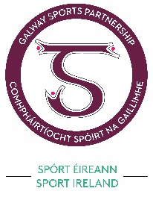
Applications received after this time will not be considered.

In association with Galway Sports Partnership

