List of Questions to aid completion of Application

COMMUNITY ENHANCEMENT PROGRAMME
2021
Funded by the Department of Rural and Community Development

NOTE: Closing Date Friday, 18th June, 2021 at 5pm



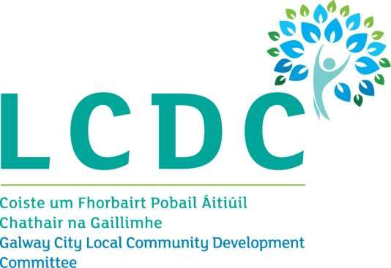

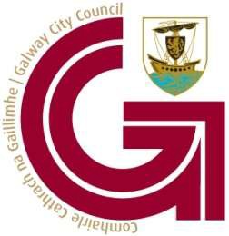

ALL APPLICATIONS ARE TO BE MADE ONLINE TO:

www.galwaycity.ie/cep2021

By 5pm on Friday 18thJune 2021
CLOSING DATE WILL BE STRICTLY ADHERED TO.

SECTION 1 – YOUR ORGANISATION

Name of Group / Organisation Address
Eircode Contact name
Role in Group/Organisation Telephone number
E-mail Website
Alternative Contact name Alternative Telephone number
Alternative E-mail
Please provide a brief organisational description of your group / organisation e.g. committee structure, meeting schedule etc.

Has your Organisation / Group registered with the relevant local Public Participation Network (PPN)?
Possible Answers YES/NO
If NO, then perhaps you would consider joining the PPN. Year established

What is the purpose of group/organisation

Successful applications for funding under this programme will only be paid to the applicant organisation’s Bank Account. Please ensure you have your Bank Account details to hand
if your application is successful.

Have you received funding under any grants schemes from 2018 to current date- i.e. grants from Government Departments, Local Authority or LEADER?
Possible Answers YES/NO

If YES please give details below
- Name of scheme
- Funding organisation
- Amount received
- Date received

If any of the above funding was paid through the Local Authority, have you submitted your Bank Account Details previously?
Possible Answers YES/NO

Do you receive funding from any other organisation? Possible Answers YES/NO

If YES please give details below:

- Funding organisation
- Amount received
- Date received

Is your organisation affiliated or connected to any relevant local regional or national body? Possible Answers YES/NO

If YES please give details below:
- Name of organisation(s):
- How does your organisation link in with other organisations in your area?

Charitable Status Number (if applicable) Tax Reference Number (if applicable)
Tax Clearance Access Number (if applicable)

SECTION 2 – Project Details
How much funding are you applying for

Small scale grant of €1,000 or less
Grant in excess of €1,000

PURPOSE OF GRANT

What will the funding be used for?
Note: This list is not exhaustive, but gives examples of types of expenditure. In general, upgrades to facilities, equipment or grants towards reopening are eligible.

IT Equipment
Sports Equipment
Training Equipment
Safety Equipment
Machinery & Equipment
Energy efficient upgrade
Renovation of building
Construction works
Other (Give details)
Development of community facility
Grant towards reopening (Give details)

How does your project address social inclusion?

What is the purpose of the grant? (Outline details of the work).

Please input exact location (X-Y co-ordinates) of where the proposed project will based.
X ITM Y ITM

This information is required in ITM format. The simple guide we have provided with this form will show you how to find these on https://irish.gridreferencefinder.com/.

If this is for a specific project, when will your project begin?

If this is for a specific project, when will your project be completed?

Are all relevant permissions in place (e.g. planning, written consent from landowner/property owner if your project involves the development of a property)?

Possible Answers Not applicable/YES/NO

Is this part of a phased development and/or linked with (or funded by) other schemes operated by Government Departments or the Local Authority?

Possible Answers YES/NO
If YES please provide the details below:

FUNDING
Amount being applied for under the CEP:

If this amount is for equipment or the upgrade of facilities, please provide details for A and B and C below. If it is for a reopening cost that is not for equipment or the upgrade of facilities, please provide details for D below.

A - Is this amount a partial or total project cost?
Possible Answers Partial/Total

B - If partial, give the estimated total project cost:

C Important note: Please include supporting documentation outlined below for your project. The Local Authority may also request specific documentation to support the application e.g. Bank statement to confirm available funds.
If your total project cost is up to €3,000 then please include one written estimate/quotation. For project costs from €3,000 up to €25,000 please seek a minimum of three written estimates/quotations from independent suppliers. For all other cases, please contact Galway City Council, email Elaine Clifford at candc@galwaycity.ie for information on the required supporting documentation.

To be eligible for funding under this programme you must state where you will source any shortfall of funding. Please provide these details below.
- Source
- Amount

D- If your application is related to a reopening cost that is not for equipment or the upgrade of facilities, please provide supporting documentation below. This could include utility bills that fall due for payment in 2021. If you are unclear about what to provide, please contact the Galway City Council, email Elaine Clifford at candc@galwaycity.ie for information on the required supporting documentation.

The Local Authority may also at a later stage request specific documentation to support the application e.g. Bank statement to confirm available funds.

E – Has your organisation availed of funding under the 2018 CEP, or the 2018 Men’s Shed fund, or the 2019 CEP, or the 2019 Men’s and Women’s Shed fund, or the 2020 CEP, or any rounds of the 2020 COVID-19 Emergency Fund?

Possible Answers YES/NO
If YES, please give details of the project which received funded in 2018 and/or 2019 and/or 2020

Please state how your group proposes to publicly acknowledge the Department, LA or LCDC

The LCDC will check to ensure that this application works towards addressing priorities within its Local Economic and Community Plan (LECP) which you can access on your local authorities’ website. If your application is for an amount greater than €1,000, please complete the below table to state which key priority area(s) in the LECP this grant application relates to and the estimated number of people to benefit.

If your application is for a small scale grant of €1,000 or less, then you may wish to complete the below table, but you are not required to do so.
- Key priority area of LECP
- No. of beneficiaries

SECTION 3 - DECLARATION

  - I declare that the information given on this form is accurate and correct.

  - I confirm I have read and fully understand the Terms and Conditions of the Community Enhancement Programme 2021(see page 2 of this form).

  - I confirm that I have read the Application Guidelines for the Community Enhancement Programme 2021prior to completing this form.

  - I confirm that this grant application is submitted in acceptance of and compliance with the Terms and Conditions.

  - I confirm that the applicant group/organisation does not have the funding to undertake the work/project without this grant aid or alternatively that the grant will facilitate a larger project which they would otherwise be unable to afford.
  - I confirm that the applicant group/organisation is tax compliant (if tax registered)
Name (on behalf of group/ organisation):
Signature:
Position held in group / organisation:
Date:

