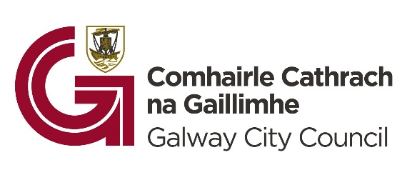

Galway City Council Arts Grant 2024

Frequently Asked Questions
Q. I cannot remember my username/password. How can I resume a previous application?
A. If you cannot remember your username, please check the automated email issued from Galway City Council Arts Office that you received when you initiated your application process.
Unfortunately, we cannot retrieve your password. Please make note of your password details when you start the process. You may need to start a new application if you lose it.

Q. What happens if I submit more than one application?
A. Galway City Council can only evaluate one application per organisation/ company. If you lost your log in details and had to start a new application, we will evaluate the application that has been received closest to the 22nd January deadline.

Q. Which strand should I apply for?
A. Professional Arts Organisations are eligible for the Professional Strand; including:

- Not for profit Arts Organisations, including companies limited by guarantee (CLG), designated activity companies (DAC) and partnerships,
- Organisations with good governance practices,
- Organisations that deliver high-quality ambitious programming and projects,
- Organisations based in Galway City and operating in the city,
- Organisations that work in creative art forms including music, film, theatre, dance, circus/street arts, visual arts, multi-media, combined arts, literature, architecture, traditional arts, interdisciplinary practices and other artforms.

If your organisation has more of a community/social purpose and runs on a voluntary basis, you can apply to the Community, Voluntary and Amateur Strand (CVA). Please read the guidelines carefully before making a decision about which strand to apply for.

Q. I don’t think my group/ project is eligible for these grants. Will there be other funding opportunities?
A. Yes, there will be other funding available from Galway City Council Arts Office for individual creative practitioners and also for creative projects through the Creative Ireland stream. These funding opportunities will be launched in spring 2024. Galway City Council Community Section manage a grant scheme for community festivals which launches later in the calendar year.

Q. Where can we enter supporting text for the images/video links attached?
A. There is no text box specific to this. You can make reference to your supporting images/video links in relevant sections.

Q. I am unable to upload documentation via the links provided.
A. This may be a technical issue depending on your connection and coverage in your area. You could try to refresh the page. You could also try a different browser, or a different internet connection.

Q. I have forgotten my Unique ID number that I used last year. What do I do?
A. In 2024, we are not utilising the ‘Unique ID system’. You will not be asked for a Unique ID, and so will not need one.

Q. Can I meet with the Arts Office staff to discuss my application?
A. The Arts Office staff cannot meet with applicants while the grant scheme is open. If you have any specific questions, send them to the Arts Office with the subject line ‘Arts Grants query’ and we will prepare a written response that can also be added to the FAQ for all applicants.

Q. Our organisation is running our annual programme of events, as well as a festival in 2024. Should I apply twice?
A. Galway City Council can only accept one application per organisation. It is recommended that you review the guidelines and that you include all your activity that is eligible under the scheme.

Q. Can I add a title and description to an image, video or sound files in my application form?
A. Yes, when you click to upload your file and then select your file, a title and comment box will pop up. Add a description and explanation of the context of your image/video/sound file in this location. This the process for each file.

