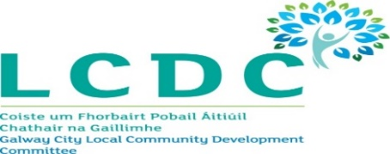
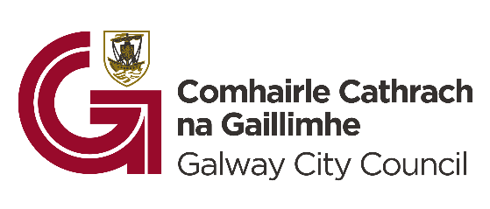
Request for Partnership Proposals: An Innovative City Initiative (2025)

1. Introduction
Galway City Council is seeking partnership proposals from qualified and experienced organisations within Galway City to participate in a collaborative initiative under the ‘An Innovative City’ programme. This programme is a strategic element of the Galway City Local Economic and Community Framework Plan 2024-2029 – with specific focus on implementation activities for 2025.

2. Background and Context
In January 2024, Galway City Council adopted the Galway City Local Economic and Community Framework Plan 2024-2029 – alongside its two year Implementation Plan for 2024 – 2025 Galway City Local Economic and Community Implementation Plan 2024-2025 . The Plan outlines key objectives to strengthen Galway’s position as a sustainable, inclusive, safe, innovative, and creative city region.

‘An Innovative City’ builds on progress made in 2024 and supports the LECP’s High Level Goal 2, which focuses on innovation, sustainability and economic resilience through collaboration.

3. Objectives of the Initiative
Galway City Council is seeking partnership proposals from qualified and experienced organisations within Galway city to co-develop and deliver collaborative initiatives that promote innovation, creativity and sustainable economic development. These should aim to achieve outcomes for one of the following priority objectives:

- Supporting the development of the social and circular economy
- Fostering a spirit of creativity, innovation, and entrepreneurship
- Ongoing development of Innovation Ecosystem
- Advancing the digital and green transformation of enterprise

Support will be provided by Galway City Council towards the development and implementation / delivery of their project, which must be collaborative in nature and provide added value.

4. Eligibility and Partnership Criteria
Proposals are welcome from organisations based in Galway City that:
- Have demonstrable experience in delivering economic or innovation focused initiatives.
- Can collaborate with Galway City Council and relevant stakeholders.
- Are able to co-fund at least 20% of proposal costs (cash or in-kind contributions accepted).
- Proposals under this initiative must be completed before the end of 2025 and show realistic, actionable timelines.

5. Proposal Requirements
Initial proposals should be a maximum of three pages and include the following:
- A brief overview of the proposal including its goals, expected outcomes and timeline.
- A description of how the proposal will be implemented collaboratively with Galway City Council and others.
- An explanation of the innovative aspects of the proposal and alignment with the LECP Implementation Pan 2024 – 2025 objectives (High Level Goal 2).
- A detailed budget including estimated costs, resources required, in-kind contributions and confirmation of match funding.

6. Evaluation Criteria
Proposals will be evaluated based on:
- Alignment with the LECP Implementation Plan 2024–2025 objectives (High Level Goal 2).
- Strength and feasibility of the proposed collaborative approach.
- Innovative potential and practical community/economic impacts.
- Realism of the timeline and budget, including co-funding commitment.
Shortlisted proposals may be invited for further discussion and refinement in partnership with Galway City Council.

7. Submission Guidelines
- Proposals must be submitted by 5pm on Friday, 9th May 2025.
- Please email your proposal to Eimear.Coleman@galwaycity.ie with the subject line ‘Partnership Proposal - Your Organisation's Name’.
- For any queries, please contact Eimear Coleman, Economic Development at Eimear.Coleman@galwaycity.ie.

