_____________________________________________________________
Galway City Council Arts Newsletter Late August
Welcome to this fortnight’s newsletter. Below, you will find some upcoming events, along with some interesting opportunities.
Happy reading, from the Galway City Arts Office team.
_____________________________________________________________
Arts Council Funding Applications closing soon.

A reminder that two Arts Council Funding opportunities close in the coming weeks:
- Strategic Funding, 2025: closes 5th September
- Visual Arts workspace Scheme 2025 – closes 12th September
If you are applying for one of these grants, and will be seeking a Letter of Support from the Arts Office, please reach out as soon as possible by emailing arts@galwaycity.ie

More information here.
_____________________________________________________________
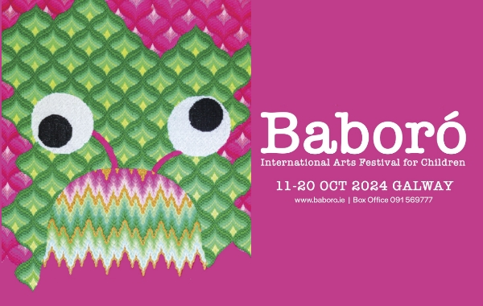

Sneak peek at 3 Baboró festival highlights

The 28th annual Baboró festival is set to take place over ten days this October (Friday 11 - Sunday 20 October). Today, we're delighted to share a first look at 3 exciting festival highlights and unveil the vibrant poster image, from the Little Monsters exhibition by Laura Angell.
The full programme will be announced Tuesday 3 September with tickets on sale Wednesday 4 September at 6pm.

More information here.
_____________________________________________________________
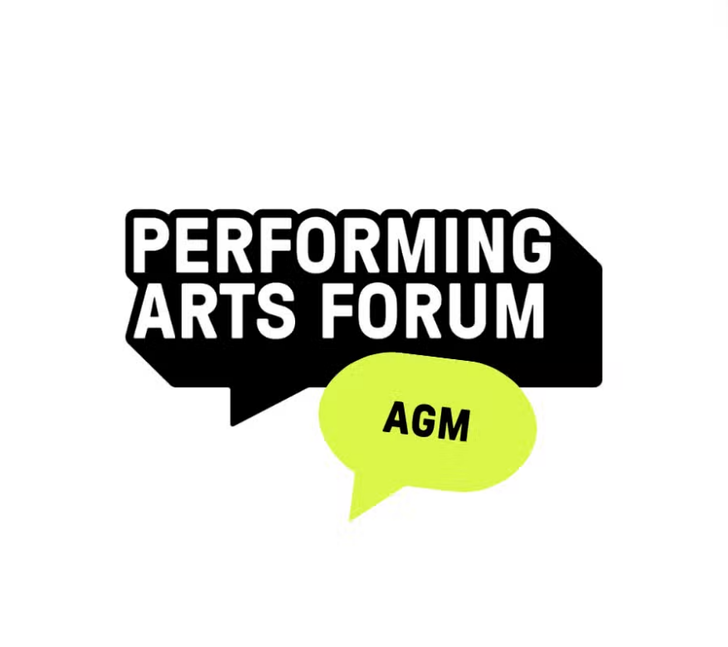

Call for Candidates - Election to the Theatre Forum CLG trading as Performing Arts Forum Board

Theatre Forum CLG, trading as Performing Arts Forum, is inviting candidates to stand for election for board positions at the company’s upcoming AGM on Friday 27 September 2024, when three of the board’s current directors will retire by rotation. They are looking for candidates who want to help make the sector stronger and the membership organisation more inclusive for future generations of artists, arts workers, and audiences.

More information here.

_____________________________________________________________
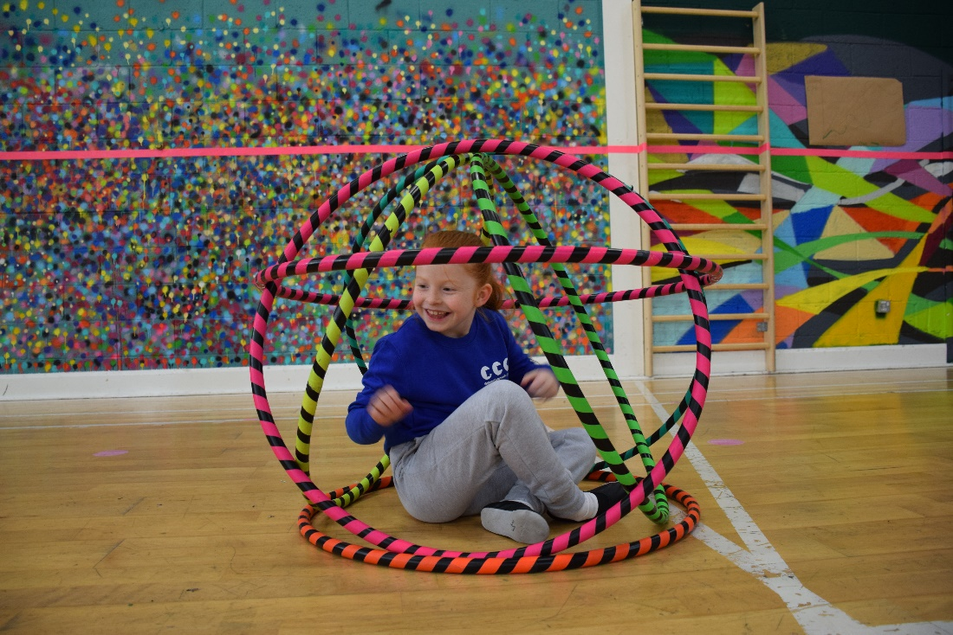

Galway Community Circus expand into Eastside

Galway Community Circus are now offering Toddler and Youth Circus classes on the Galway's Eastside at Mervue Community Centre, thanks to support from Galway City Arts Office.

In the Toddler and Youth Circus classes, children and young people will learn exciting new skills, boost confidence and creativity, participate in engaging and inclusive activities, get great exercise, and thrive in a fun, non-competitive environment.

More information here.

_____________________________________________________________
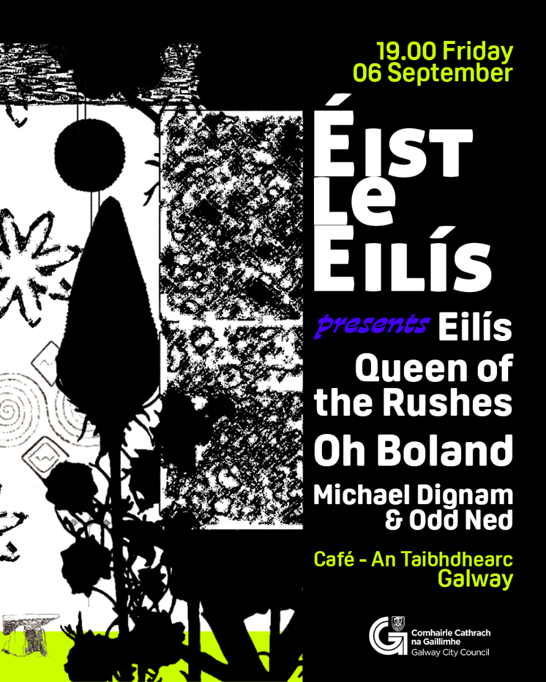
Poster Design - Aoife Anna Mullan

Éist Le Eilís presents Eilís Queen of the Rushes, Oh Bolan, Michael Dignam, Odd Ned

Eilís has brought together a diverse and respected selection of musicians - an eclectic mix of Trad, Showband skronky tonk, and Dj sets from Ireland's finest. Taking place in the intimate setting of Café An Taibhdhearc in Galway City, this promises to be a night not to miss.

More information and tickets here.
_________________________________________________________
Galway City Library Art Exhibition

Local Artist Siobhán Moore invites you to “As far as the I can Sea”, an art exhibition inspired by feelings that are evoked while surrounded by the infinite blue space of the Atlantic Ocean.

The opening reception is on Thursday the 22nd of August in Galway City Library at 6pm. The exhibition is open from the 19th until the 31st of August.

More information here.
_________________________________________________________
Range of courses available through Creative Futures Academy
Creative Futures Academy are offering funding supports on many of their courses. The courses are designed to cater to artists, creative practitioners and working professionals.
For more information about Creative Futures Academy, and the supports they offer, go to their website.
_________________________________________________________
Failte Ireland Invites Creative Events Listings
Do you have a great event happening in Ireland this year? Promote it with Fáilte Ireland!
Advertise your upcoming events to irelandwestinfo@failteireland.ie and
Register & add your events through the events portal linked to Discover Ireland.
www.FailteIrelandEvents.ie/
_________________________________________________________
Send us your Listings & News
We can share your posts! Email up to 50 words to arts@galwaycity.ie with a high-resolution landscape image. Images and text may be edited to fit.
___________________________________________________________________
GCC Arts Office Social Media
Facebook: www.facebook.com/ArtsOfficeGalwayCity
Instagram: @artsofficegalwaycity
X: @cityartsgalway
___________________________________________________________________
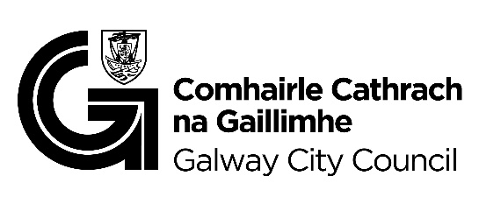

You are getting this email because you are on the Galway City Council Arts Office mailing list. Unsubscribe by emailing arts@galwaycity.ie and ask to be removed.

