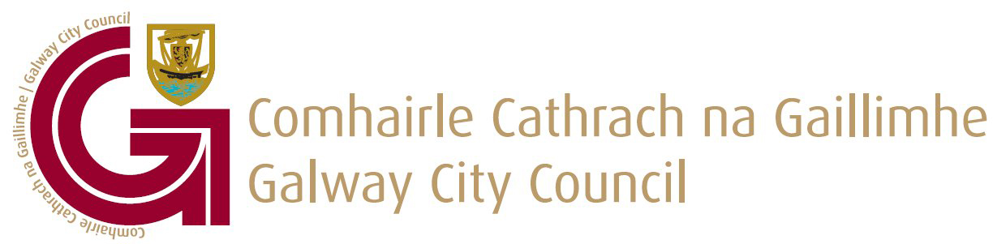

Social Inclusion Grant application form 2022

(1) Guidelines:

Galway City Council invites applications for the Social Inclusion Grant 2022 which will provide funding towards Social Inclusion projects and programmes in the city.

In order to be considered for funding the organisation or group:

- must be based in Galway City and operate within the City

- may be voluntary or operate on a not-for-profit basis

This funding is made available to groups whose projects reflect Galway City Council’s values with regards to equality, human rights, dignity, participation and inclusion. Projects should promote respect for others and encourage diversity.

Applicants should demonstrate how their projects enable and recognise the right of people, in particular those experiencing disadvantage and exclusion, to participate.

(2) General Brief for Completing the Application Form:

- Read all questions thoroughly before you answer them
- Ensure your application is clear, concise and unambiguous
- Do not assume the selection panel know you or your work
- The application is assessed on the basis of all information supplied
- Have a clear and realistic idea of what you want and how much your proposal costs
- Provide a project time-line if appropriate
- Ensure that you enclose all documentation

(3) Criteria & Conditions for Social Inclusion Grant Scheme

Galway City Council is committed to the principles of transparency and fairness with regards to the distribution of resources. Applications will be assessed by an independent committee to uphold these principles when the awarding of funds is being decided.

- All Social Inclusion Grants are offered subject to the availability of funds.
- The funding offered must only be used for the purposes specified in your application.
- The award must be spent within the current year 2022.
- Applicants must be located or provide services within Galway City Council’s administrative area.
- Assistance received through this scheme should form part of the income funding the project.
- Where a grant is allocated for a specific event / project, Galway City Council will not be responsible for the insurance of that event / project. Galway City Council recommends that the organisers ensure that adequate insurance is in place prior to the commencement of any event / project.

- If the event or project is altered, postponed or cancelled – in whole or in part – the Housing & Social Inclusion Office must be contacted in order to discuss the matter.

- Codes of Practice Observance; Child First Guidelines, Health & Safety Regulations, Equal Opportunities.

- Galway City Council must be acknowledged on all publicity, press and marketing material produced in connection with the undertaking or event.

- Copies of all such material produced must be sent to the Housing & Social Inclusion Office

- Where relevant applicants must have full and complete permission from the venue owner to hold events in said venue.

- An evaluation report regarding the event / project may be requested by the Housing & Social Inclusion Department and must be submitted within one month of such a request. Failure to comply will result in the withdrawal of the funding.

- Acceptance of these conditions is implied by submission of a completed Application Form.

- Canvassing will disqualify the applicant.

Summary

Social Inclusion Grant 2022

Email to: housing@galwaycity.ie

Applications submitted to any other email address will not be accepted

Alternatively post to:-
Housing & Social Inclusion Department
Galway City Council
City Hall
College Road
Galway

The application form may be typed or hand-written. Please complete in block capitals using additional paper where required.

Your application will be invalid if you do not:-

- Submit a fully completed and signed Application Form
- Submit all documentation with your Application Form
- Submit your application by the deadline of 4:00 p.m. Friday 10th June, 2022

Please note that the maximum attachment size on our Mail Server is 15MB

Additional Information cannot be accepted after the closing date

(4) Freedom of Information:

Galway City Council proposes that the following information relating to this grant application competition will be made available on request:
- Name of the applicants.
- Reasons an applicant did / did not qualify for grant consideration.
- Name, summary of Project and Grant amount of the successful applicants
Galway City Council undertakes to use its best endeavours to hold confidential any information provided by applicants subject to its obligations under law, including the Freedom of Information Act 1998 and 2003.

Social Inclusion grant 2022

Application Form

organisation Details:- To be completed by all applicants

Name of Group / Organisation ____________________________________

Address ____________________________________

Contact Person ____________________________________

E-mail Address ____________________________________

Contact Numbers ____________________________________

Website: ____________________________________

Briefly describe the project: / programme:- ____________________________________
___________________________________________________________________________
___________________________________________________________________________
___________________________________________________________________________
___________________________________________________________________________
___________________________________________________________________________
What is the aim of the project / programme:-______________________________________
___________________________________________________________________________
___________________________________________________________________________
___________________________________________________________________________

Who are the target groups:- __________________________________________________
___________________________________________________________________________
___________________________________________________________________________
___________________________________________________________________________

Briefly outline the costs of the project / programme:- _____________________________
__________________________________________________________________________
___________________________________________________________________________
___________________________________________________________________________

How will you measure the effectiveness of the project:- __________________________
__________________________________________________________________________

___________________________________________________________________________
___________________________________________________________________________

Name (printed): ________________________ Signature: ________________

Position: ______________________________ Date: ____________________

deadline for the receipt of applications is 4.00pm Friday 10th June, 2022

FINANCIAL INFORMATION

Account details (Please note: the only method of payment of any grant approved will be Electronic Funds transfer. If you are a first time applicant for have not already received payment from Galway City Council by EFT, please complete the official Supplier Set Up Form attached and return with your application.

If you have previously received payment from Galway City Council but have changed details i.e. Bank account, address etc. Please complete and return the official Supplier Set Up Form attached and your details will be updated on our system.

Each organisation/ group must ensure that the information provided to Galway City Council for payment of a grant is correct.

Financial Summary:
- Please provide an up to date, Certified/Audited (if applicable) Statement of Accounts with this application. If your organisation is tax registered you are required to provide a copy of a valid Tax Clearance Certificate. This is not necessary if you can quote a Charity Number.

