Healthy Age Friendly Homes Programme
The National Programme is delivered across all 31 Local Authorities and has at least one local support coordinator in each Local Authority.
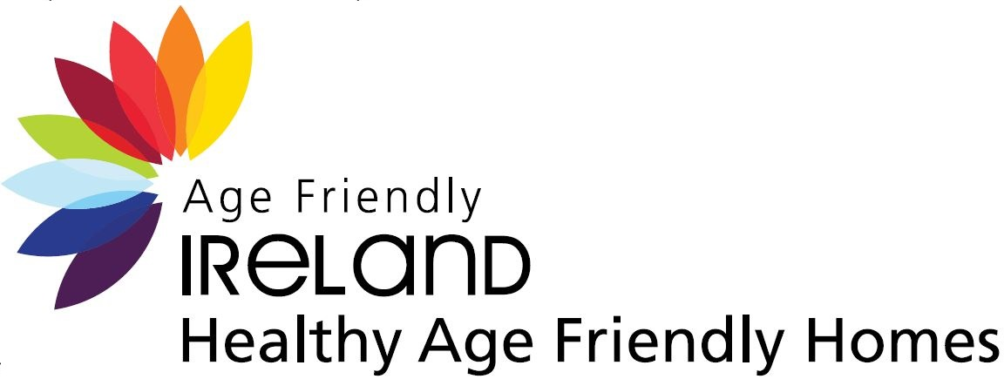

The Healthy Age Friendly Homes Programme aims to support older people to live in their own home with dignity and independence, for as long as possible. The programme’s ambition is to enable everyone to live longer healthier lives by keeping care close to home and expanding the range of health and social care services in the community. It is about providing a range of alternatives for older people who may otherwise transition into long term residential care prematurely.
To do this, we have appointed a Local Healthy Age Friendly Homes Coordinator in all local authorities. Each Local Coordinator will case manage a support package for each person referred, linking the supports from the variety of public, voluntary, private and community agencies in the area.
The purpose of this referral is to identify an older person who could benefit from some extra help and support in order to continue living in their own home. The Local Coordinator will carry out a free home-based assessment and, in partnership with the older person, will identify and design a range of supports to enable the older person to continue living independently. This will not affect any current home help, medical card, pension, or other services being received.
Check out our Participants video, Mary Kelly: Health Age Friendly Homes Case Study | Health & Finance (youtube.com)
Check out our Participant video Nola Watt Healthy Age Friendly Homes Case Study | Rightsizing (youtube.com)
Find out more at https://agefriendlyireland.ie/healthy-age-friendly-homes-programme/

Contact HAFH
Email Referrals
referralshafh@meathcoco.ie
Email Admin
healthyagefriendlyhomes@meathcoco.ie
Address
Meath County Council
Kells Civic Office
Headfort Place
Kells, Co. Meath
A82 W2R3
Phone
046-924 8899

