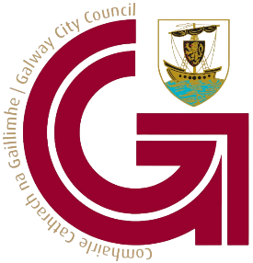 | Galway City Council Arts Office Acknowledgement Guidelines  2023

Introduction
Organisations, group, events, venues or individuals in receipt of Galway City Council Arts Office funding must acknowledge that support in all signage, printed ephemera, press releases or other public forums. Acknowledgement may be in writing or by the inclusion of our logo, where possible please include both.

Our Logo
Our logo may be used in one of the formats shown below. The colour palette should not be altered. The logo should be a sufficient size to be clearly legible. For the Galway City Council logo to maintain impact, the surrounding area must be open and uncluttered. When placing the logo close to graphic elements, clear space must be maintained on all sides.
When using the Galway City Council logo in conjunction with other logos, please ensure that it has the same prominence and is sized appropriately to match the shape and size of the other logos displayed.
Where Galway City Council is the primary funder, the logo must be the most prominent and should appear first in a logo line up.
In both horizontal and vertical situations, the council logo must never be rendered smaller than any other logo being display in the same visual area. These Logos are available to download from our website here.

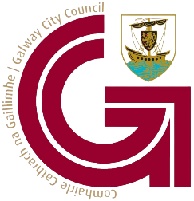
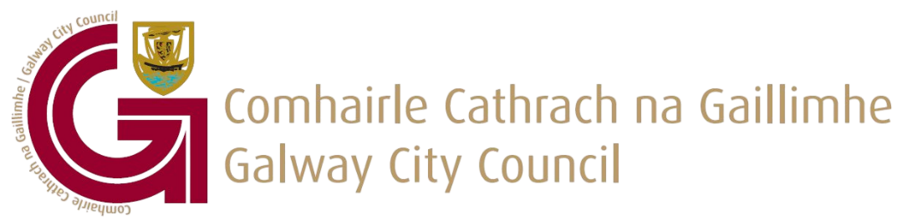
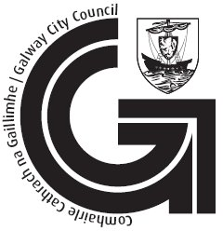
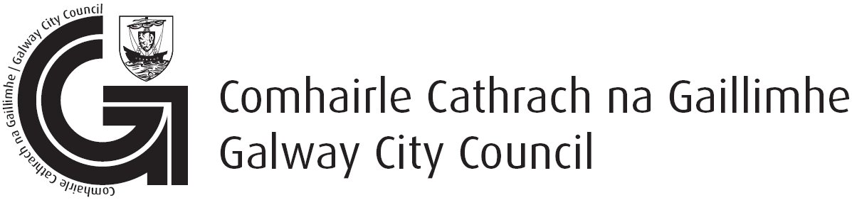
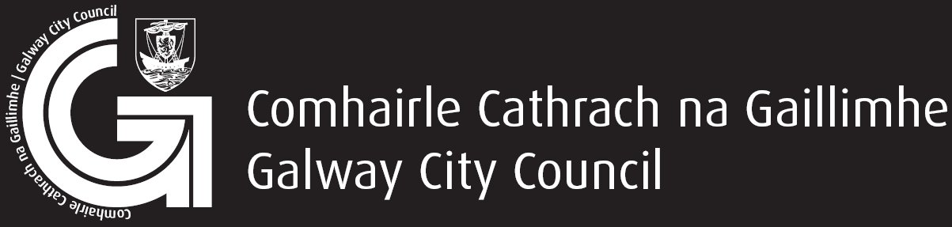

Written Acknowledgement
Written acknowledgement must be made in English and Irish. Below are some examples of how you can acknowledge the support of Galway City Council Art Office.
English | Irish
This event was made possible by the support of The Galway City Arts Office. | Bhí an ócáid seo indéanta le tacaíocht ó Oifig Ealaíon Chathair na Gaillimhe.
This programme was made possible by the support of The Galway City Arts Office. | Baineadh an clár seo amach le tacaíocht ó Oifig Ealaíon Chathair na Gaillimhe.
This series was made possible by the support of The Galway City Arts Office. | Cuireadh an tsraith seo ar fáil le tacaíocht ó Oifig Ealaíon Chathair na Gaillimhe.
“Tittle of event/series/programme” was made possible by the support of The Galway City Arts Office. | Baineadh “Teideal na hócáide/na sraithe/an chláir” amach le tacaíocht ó Oifig Ealaíon Chathair na Gaillimhe.
We are proudly supported by The Galway City Arts Office. | Faighimid tacaíocht ó Oifig Ealaíon Chathair na Gaillimhe.
“Name of Organisation” is proudly supported by Galway City Arts Office. | Faigheann “Ainm na hEagraíochta” tacaíocht ó Oifig Ealaíon na Gaillimhe.

Social Media Handles
Twitter | @GalwayCityCo
Instagram | @GalwayCityCouncil
Facebook | @GalwayCityCouncil

